3GPP TSG RAN WG1 Meeting #125 R1-2604697

Dalian, China,

May 18th-22nd, 2026

Agenda item: 10.5.2.2

Source: Qualcomm Incorporated

Title: Downlink transmission scheme(s) for downlink shared channels

Document for: Discussion/Decision

Introduction
In this paper, we present our view on potential enhancements for PDSCH, focusing on the following aspects
- PDSCH frequency domain interleaving
- Transmission scheme enhancements including explicit CDD and Spatially-coupled-MIMO (SC-MIMO)
- PxSCH DMRS pattern design
- Spectrum aggregation considerations

PDSCH Frequency domain interleaving
In NR design, in order to harvest frequency diversity for PDSCH, VRB2PRB mapping was introduced as an optional feature. The modulated symbol stream of a codebook will be filled first across spatial layers of an RE, then across frequency follows VRB index, and then across time over different OFDM symbols. When VRB2PRB mapping feature is turned on, a block interleaver with two (hard coded in spec) columns is used to distribute the VRB over the entire BWP. As a result, a diversity level of 2 in frequency domain can be achieved.
For 6GR, given the wide bandwidth of channelization, the legacy NR VRB2PRB mapping leaves large degree of frequency diversity on the table. One direction to improve is to harvest larger diversity by introducing better frequency domain interleaving.
Ideally, we can use RE level interleaving to uniformly distribute REs of each CB over the entire allocated bandwidth, which will achieve the highest diversity level. However, if RE level interleaving is used, when processing one code block, the receiver needs to collect REs distributed over the entire allocation. When the channel estimation is done at PRG level, this implies that the UE needs to collect estimated channel of all PRGs the REs of a CB are distributed into and compute LLRs for a small sub-set of REs from each PRG. This leads to inefficient processing. On the other hand, each CB already occupies quite a few RBs, even at the highest spectrum efficiency. If we interleave at PRG level (say 4 RBs), we can already collect most of the frequency diversity. For example, at peak MCS with 256QAM, and rank 4, a CB occupies about 24 PRBs (or 6 PRGs with PRG size 4). A diversity level of 6 is typically considered good enough.
Observation 1: Improved PRG level interleaving can achieve the same frequency diversity order as the # of PRGs in a CB
With a block interleaver, we need to determine the parameters of the interleaver, i.e., the interleaving depth, which is equivalent to the number of rows R of the interleaver matrix. To maximize the diversity level, it is preferred to distribute the PRGs of a CB uniformly over the allocated bandwidth. A simple design can be, the number of rows of the block interleaver approximately match the number of PRGs a CB occupies, which is a function of MCS and rank of the transmission.
A simple way to compute $R$ as a function of allocated REs (from FDRA and TDRA) and number of CBs is given by $R≈\frac{Number of allocated REs}{12×PRG size}×\frac{1}{Number of CBs}$, where the number of allocated REs can be derived from FDRA and TDRA. The number of columns is $C=\left\lceil N_{PRG}/R\right\rceil$. If $R$ does not divide $N_{PRG}$, some NULLs can be inserted in the block interleaver to facilitate the interleaving process.
Figure 1 shows and example of PRG level block interleaver with 72 PRGs in the allocation and $R=8$. In this example, a CB occupying about 8 PRGs (virtual PRG 0 to part of virtual PRG 7) will be uniformly distributed to physical PRG 0, 9, .., 63, to achieve the maximum frequency diversity available.
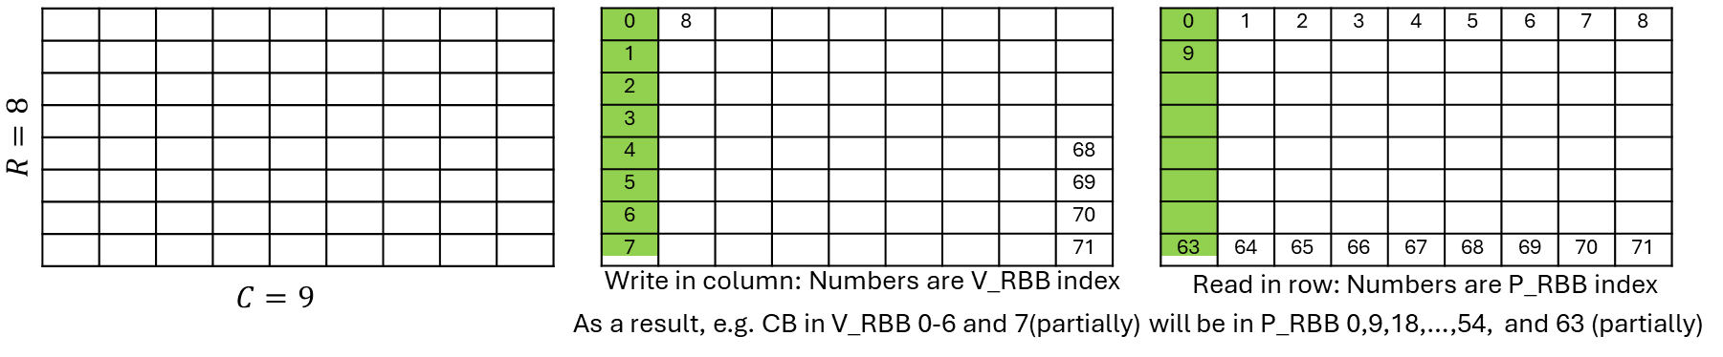
Figure 1. Example for block interleaver for PRG level interleaving
Figure 2 shows the throughput comparison of 6GR interleaving scheme and baseline schemes of no frequency domain interleaving and legacy NR VRB2PRB mapping for a CDL-A channel with RMS delay of 30ns in a 8Tx, 4 Rx MIMO setup with beamforming and link adaptation enabled, for CBW of 400MHz and 100MHz. As seen from the both plots in this figure, the PRG level interleaving with R chosen based on number of PRGs in a CB outperforms the other two methods, with a gain of ~1.5dB and ~0.7 dB at SNR of 25dB for 400MHz and 100MHz CBW cases. Gain is more significant in larger CBW since PRG level interleaving is able to harness higher frequency diversity from channel fading in a wider bandwidth. Fig 3 further show the performance comparison of 6GR interleaving scheme with respect to tone-based interleaving and baseline schemes of NR VRB to PRB mapping for a BW allocations of 200MHz with CDL channel sweep of 30ns, 100ns and 300ns of RMS delay. Across the CDL channel models, 6GR interleaving scheme is shown to provide some gains over the NR scheme and is very close to the tone interleaver performance.
Proposal 1: Study a RBB (match the size of a PRG) level block interleaver to maximize the frequency diversity of PDSCH where the interleaving is over all the PRGs allocated for the PDSCH
Proposal 2: Consider the block interleaver depth or the number of rows of the block interleaver to approximately match the number of PRGs a CB occupies.
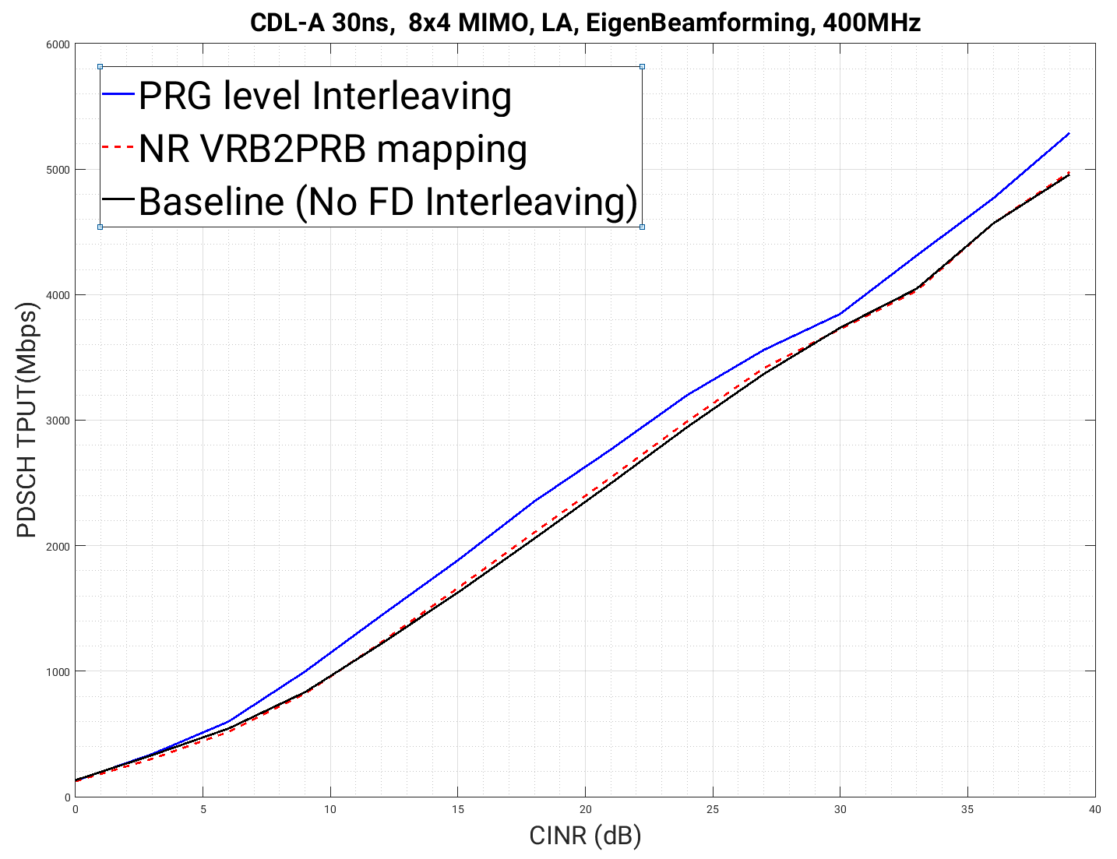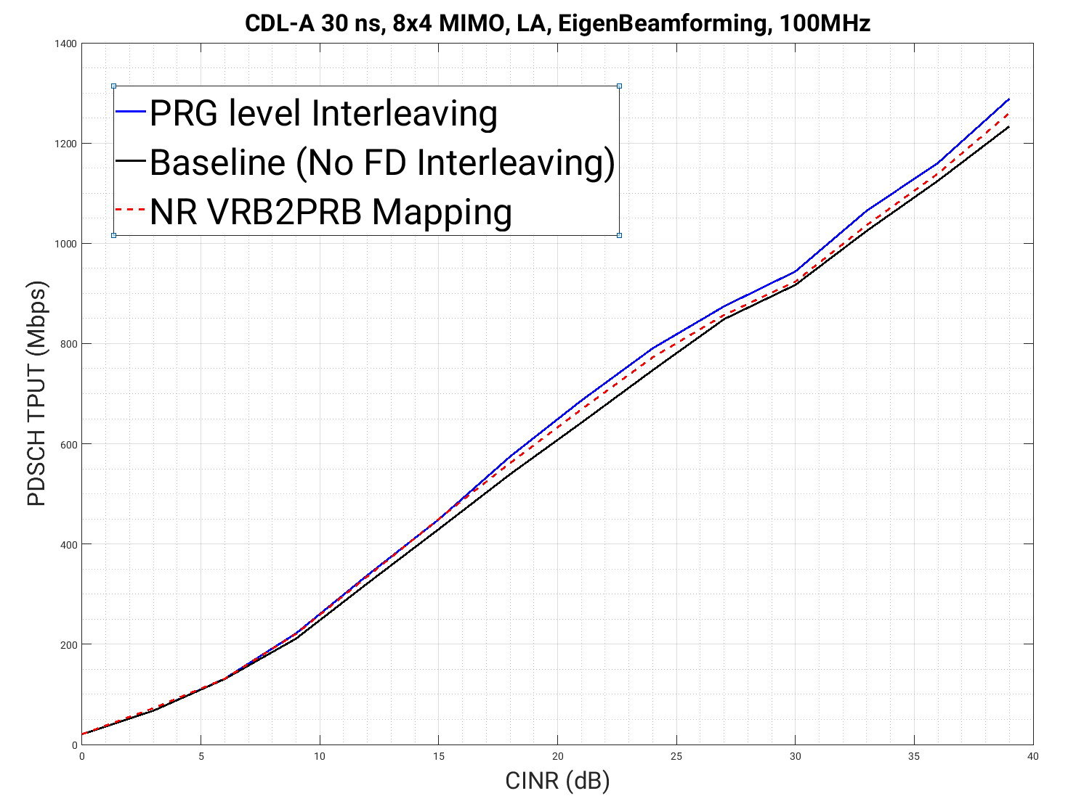
Figure 2. PDSCH Throughput performance with PRG level interleaving
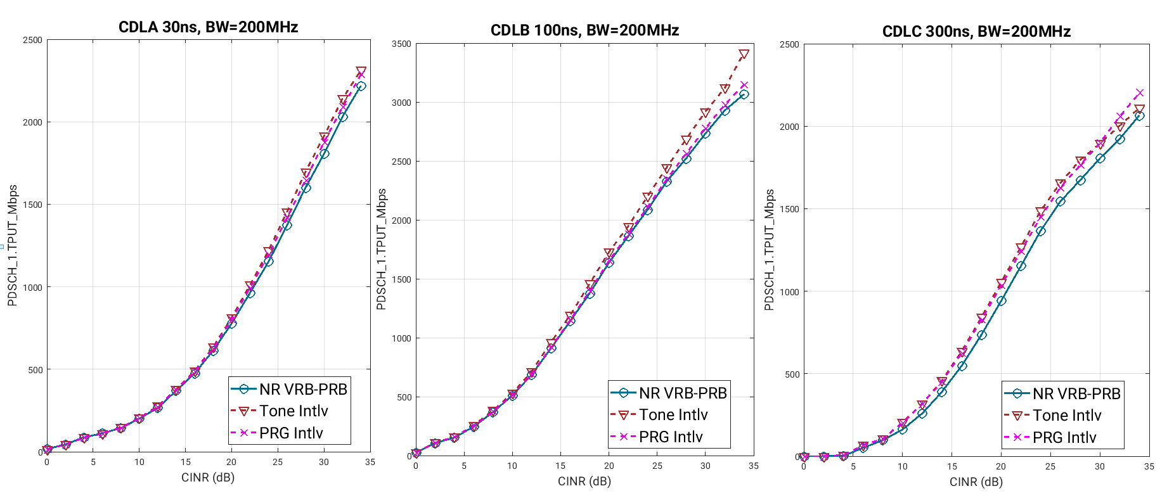
Figure 3. PDSCH Throughput performance with PRG level interleaving (8x4 MIMO)

Transmission enhancements

Explicit CDD
Transmit diversity is primarily used as a fallback transmission scheme when accurate CSI is unavailable, for example for improving the coverage of broadcast data/control channels, DL messages before RRC connection establishment, or high Doppler scenarios. In massive MIMO scenarios, transmit diversity can also operate in semi-open-loop manner, where a wideband beam/basis is applied per POL/panel based on beam/basis sweeping or wideband CSI feedback, while a given transmit diversity scheme is applied across POLs/panels to obtain diversity gain. Unlike LTE which adopted SFBC, NR didn’t explicitly define a transmit diversity scheme in the spec under the assumption that transparent transmit diversity schemes such as PRG-level precoder cycling or transparent small-delay CDD can play a role for a sufficient diversity gain, even compared to LTE SFBC.
SFBC is a transmit diversity scheme for single-layer transmission with two RS ports that achieves the full diversity gain. However, since the number of RS ports is inconsistent with the number of PDSCH layers, SFBC complicates the UE implementation and advanced interference-aware receiver operation. Also, the RS overhead due to the additional RS port makes SFBC less attractive, which is the reason why it was not adopted in NR.
To achieve reasonable diversity gain while maintaining consistency between data and DMRS transmission, i.e., single-layer data and single-port DMRS, CDD and precoder cycling are still promising transmit diversity schemes for 6GR, with the same rationale as in 5G NR. However, a key topic for further discussion in 6GR is whether such diversity schemes should remain transparent to the UE or be explicitly defined in the spec.
PRG-level precoder cycling cannot provide sufficient diversity gain for narrowband resource allocation cases. When the PRG size is 4, PDSCH occupying fewer than 4 RBs cannot utilize PRG-level precoder cycling. Even for PDSCH allocations of 8, 12, or 16 RBs, only 2, 3, or 4 distinct precoders can be applied, respectively. This limited number of precoders restricts the achievable diversity gain. Additionally, PRG-level precoder cycling does not guarantee the phase continuity across PRGs, thereby restricting the UE to apply only PRG-level narrowband channel estimation, even in case of wideband PDSCH resource allocations, which may reduce the potential frequency-domain processing gain.
Alternatively, CDD achieves diversity gain by applying different cyclic delays across the transmit branches of the same signal as shown in Figure 4. Since the cyclic delay translates to the linear phase ramp in the frequency domain, CDD maintains the phase continuity across frequency. In other words, CDD can be interpreted as phase-continuous RE-level precoder cycling in the frequency domain, which enables the use of wideband DMRS channel estimation in the UE receiver. Therefore, CDD can potentially provide diversity gain even for narrow band resource allocation cases as well as exploit frequency-domain processing gain for wideband resource allocation cases.
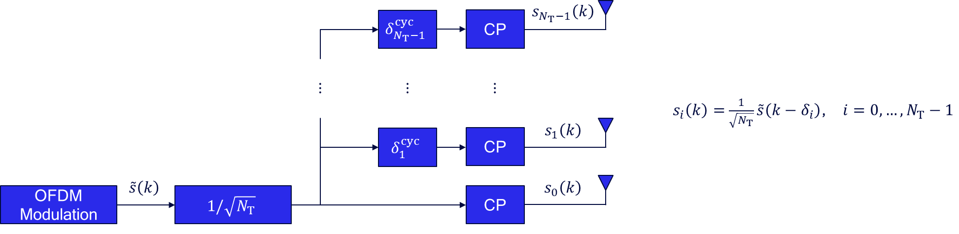
Figure 4. Single-layer CDD precoding
However, to fully harvest the CDD gain, the explicit signaling of the cyclic delay value is beneficial for the UE to capture the inherent shift on the channel power delay profile (PDP) induced by CDD as shown in Figure 5. In this example, the single-layer PDSCH/DMRS has been precoded with CDD over two transmit antennas, which resulted in two channel PDPs shifted by different cyclic shift values corresponding to transmit antenna 0 and 1 (red dash). Without CDD, the two channel PDPs of transmit antenna 0 and 1 would have been superimposed on top of each other (blue solid). In practice, the UE performs DMRS channel estimation based on the channel PDP acquired from the TRS. However, the channel PDP of the CDD-precoded DMRS (red dash) would deviate from that of the TRS (blue solid) unless the TRS has also been precoded with CDD. To avoid such mismatches without the explicit signaling of the cyclic delay value, the delay values used in transparent CDD must be constrained to a ‘very’ small value, which in turn limits the achievable diversity gain.
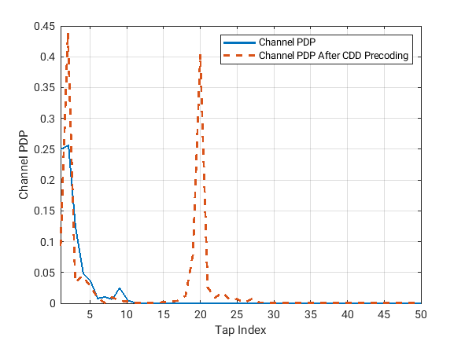
Figure 5. Channel PDP before and after CDD precoding over two transmit antennas
To explore various gains offered by CDD over 4-RB PRG-level QPSK-based precoder cycling, the LLS is conducted for narrowband and wideband PDSCH where the gNB and UE are equipped with 2/4 transmit and 4 receive antennas, respectively. For CDD, the cyclic delay value is selected such that the required SNR for achieving the 10% BLER is minimized. The details of the LLS setup are provided in Table 1.
Carrier BW | 100 MHz
SCS | 30 kHz
Channel model | TDL
Delay spread | {30, 100} ns
UE speed | 3km/h, 60 km/h
gNB array | 2/4 transmit antennas
UE array | 4 receive antennas
PDSCH F/TDRA | {8, 48} RBs x 10 symbols with 2 DMRS symbols
MCS | MCS 8 (16QAM, R = 553 / 1024) from 256QAM table
DMRS channel estimation | RMMSE-based under PRG bundling size {4, wideband}
Table 1. LLS setup for CDD evaluation
The CDD gain over PRG-level precoder cycling shown in Figure 6 through Figure 9 has two folds provided that the cyclic delay value is explicitly signaled. First, CDD offers a significantly higher degree of diversity gain compared to PRG-level precoder cycling as evident from CDD combined with narrowband channel estimation (blue cross). This can be attributed to the fact that the number of distinct precoders that can be applied by PRG-level precoder cycling is limited to 2 across 8 RBs consisting of 2 PRGs, while CDD can fully cycle the precoder in the RE-level granularity. Additionally, the CDD gain can be further enhanced by realizing the frequency-domain processing gain through wideband channel estimation (red cross) although the improvement is less pronounced due to the narrow resource allocation. CDD enables the use of wideband channel estimation by maintaining the phase continuity across the REs. In contrast, PRG-level precoder cycling is always restricted to narrowband channel estimation as the phase continuity is not guaranteed across the PRGs. Note that in high-speed scenario (60 km/h), CDD can show a significant performance benefit even compared to closed-loop precoding schemes.
The CDD gains discussed until now were achieved with the knowledge of the cyclic delay value, based on which the UE makes a correct assumption on the CDD-shifted channel PDP. In the absence of such information (blue/red circle), performance degradation is inevitable, especially in case of the low delay-spread channel.
Observation 2: Under narrow resource allocation, the CDD gain over PRG-level precoder cycling mainly originates from the higher degree of diversity gain
Observation 3: CDD gain can be further enhanced by employing wideband channel estimation, which is not possible with PRG-level precoder cycling
Observation 4: Explicit indication of the cyclic delay value is beneficial for UE to make a correct assumption on the CDD-shifted channel PDP
Figure 6. Narrowband PDSCH BLER spanning 8 RBs (2 Tx, 3 km/h)
Figure 7. Narrowband PDSCH BLER spanning 8 RBs (2 Tx, 60 km/h)

Figure 8. Narrowband PDSCH BLER spanning 8 RBs (4 Tx, 3 km/h)
Figure 9. Narrowband PDSCH BLER spanning 8 RBs (4 Tx, 60 km/h)
Moving on to the wideband PDSCH spanning 48 RBs as shown in Figure 10 through Figure 13, most of the CDD gain is now shifted towards the realization of the frequency-domain processing gain when the cyclic delay value is known. Unlike the narrow resource allocation case, PRG-level precoder cycling now achieves full diversity gain as all its precoders are cycled multiple times, i.e., 4 precoders cycled 3 times across 48 RBs. As a result, CDD combined with narrowband channel estimation (blue cross) provided limited gain over PRG-level precoder cycling. In contrast to the narrow resource allocation case, however, significant frequency-domain processing gain can be achieved when wideband channel estimation is combined with CDD (red cross) due to the leap from 4-RB processing to 48-RB processing. Again, note that the phase continuity of CDD precoding enables the use of wideband channel estimation, which is not possible with PRG-level precoder cycling due to its discontinuous phase across the PRGs. In high-speed scenario (60 km/h), CDD also shows a significant performance benefit even compared to closed-loop precoding schemes.
Similar to the narrow resource allocation case, the UE knowledge of the cyclic delay value is beneficial for realizing the observed CDD gain. If the cyclic delay value is unknown to the UE (blue/red circle), performance degradation is inevitable due to the incorrectly assumed channel PDP. The impact of the mismatch is more pronounced in case of the low delay spread, i.e., 30 ns.
Figure 10. Wideband PDSCH BLER spanning 48 RBs (2 Tx, 3 km/h)
Figure 11. Wideband PDSCH BLER spanning 48 RBs (2 Tx, 60 km/h)
Figure 12. Wideband PDSCH BLER spanning 48 RBs (4 Tx, 3 km/h)
Figure 13. Wideband PDSCH BLER spanning 48 RBs (4 Tx, 60 km/h)
Observation 5: Under wide resource allocation, most of the CDD gain over PRG-level precoder cycling is attributed to the realization of the frequency-domain processing gain
The SNR required to achieve 10% BLER for different cyclic delay values is provided in Figure 14 for both the narrow and wide resource allocation cases under the low delay spread setup, based on which optimal cyclic delay values were selected when conducting the LLS for CDD. The unit of the cyclic delay value is the OFDM waveform sampling period. The considerable gain offered by the knowledge of the cyclic delay value observed in Figures 5-8 under the low delay spread setup with wideband channel estimation can be attributed to two reasons as evident from Figure 14. First, the knowledge of the cyclic delay value aids the UE to properly align its assumed channel PDP with the CDD-precoded channel PDP, which leads to better channel estimation performance. Second, the knowledge of the cyclic delay value enables the use of a large cyclic delay value. Note that the optimal cyclic delay value in terms of the 10% BLER is relatively large. If the UE is ignorant of the CDD-shifted channel PDP, the diversity gain offered by the large cyclic delay value would be countered by the poor channel estimation quality. This suggests that in general, CDD should be supported in an explicit fashion to unlock the full potential.
Observation 6: Explicit CDD allows the UE to employ CDD precoding with large cyclic delay values when needed
Proposal 3: Study the explicit CDD for 6GR transmit diversity
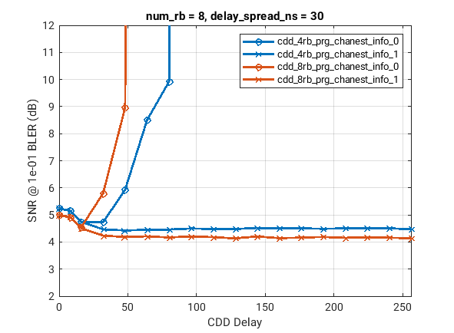 | 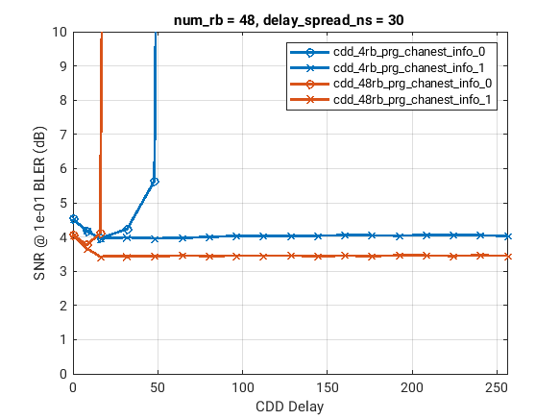
Figure 14. Required SNR for achieving 10% BLER for different cyclic delay values

New codeword to layer mapping enabling native SIC
In 5G NR, a single codeword is used up to 4 spatial layers and the codeword-to-layer mapping follows the order as shown on Figure 15. This mapping requires a non-linear demapper such as rML for good performance and is not capacity-achieving unless the receiver iterates between the demapper and the decoder.
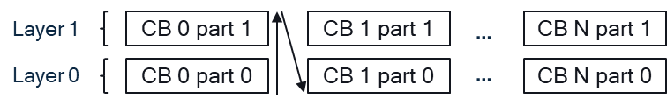
Figure 15. 5G NR layer mapping
In order to address this, a new layer mapping can be considered. Instead of stacking the code blocks vertically, we introduce a staggered structure akin to a cyclic shift of a subset of the spatial layers. Figure 16 captures the main essence of the proposed mapping for the case of two layers. Drawing an inspiration from spatially-coupled LDPC codes where the decoding wave propagates through the nodes when the decoding progresses, we call this new mapping spatially-coupled MIMO (SC-MIMO). The structure extends naturally for more than two layers, in which case the layers are grouped together and the staggering is performed for layer groups instead of the individual layers.

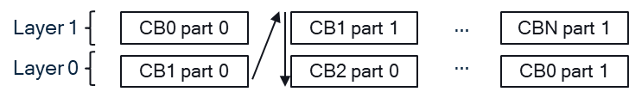
Figure 16. Spatially coupled MIMO layer mapping
The mapping structure alone provides an additional frequency diversity gain but an even greater performance gain can be achieved by using the successive interference cancellation (SIC) at the receiver side. That is, after demodulating and decoding CB 0, it can be re-encoded and subtracted from the received signal before proceeding to process the next CB. In that case, the staggered structure ensures that some part of each CB sees an improved channel condition compared to 5G NR mapping due to the reduced interference. In case of two layers, each CB is split into two parts, where part 1 sees the same channel as in the case of NR mapping with the interference from layer 0, while part 0 is interference-free from SIC. It follows that the collective channel quality that each staggered CB sees in case of SC-MIMO mapping is better compared to the vertical mapping used in 5G NR when SIC is utilized at the receiver side.
Observation 7: Staggered CBs in SC-MIMO mapping see better channel quality compared to NR mapping assuming SIC receiver
Due to the interference cancellation, the effective channel for some part of each CB becomes low-interference (or in case of 2 layers interference-free). In addition, the demapper of the low-interference channel operates in the regime when the number of receive antennas is larger than the number of spatial layers, which would further reduce MIMO demod complexity without a degradation in performance.
Observation 8: SC-MIMO mapping enables low-complexity demapping of the low-interference layers
Next, we evaluate the performance of the new MIMO mapping. The evaluation assumptions are given in Table 2. We performed the OLLA throughput evaluations assuming rank-2 and rank-4 transmissions.
Table 2. Layer mapping evaluation assumptions
Carrier BW | 20 MHz
SCS | 15 kHz
Channel model | CDL-A, 30ns
UE speed | 3km/h, 30 km/h
gNB array | 32 TXRUs, 16 AE, (M,N,P)=(4,4,2)
UE array | 4 TXRUs, (M,N,P)=(1,2,2)
Precoder | SRS-based SVD, SRS periodicity 40 slots
DMRS channel estimation | RMMSE-based under PRG bundling size 4
Receiver | rML/rML+MMSE after SIC
Layer mapping scheme | NR MIMO, SC-MIMO, 2CW

Figure 17 demonstrates the results for rank-2 transmissions. We observe that the for the 3km/h speed scenario, all layer mapping schemes perform closely, demonstrating that layer imbalance does not negatively affect the performance of the single-codeword transmissions and inter-layer interference is small. On the other hand, for the higher speed when the beamforming becomes less accurate, inter-layer interference starts to impact the performance of NR MIMO and SC-MIMO provides more than 0.5dB performance gain by effectively handling it.
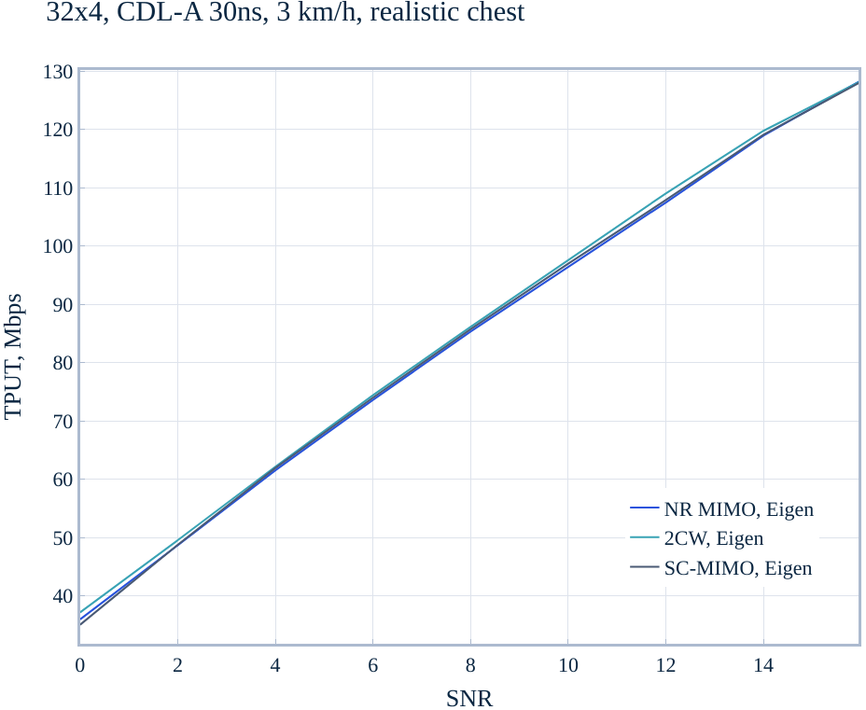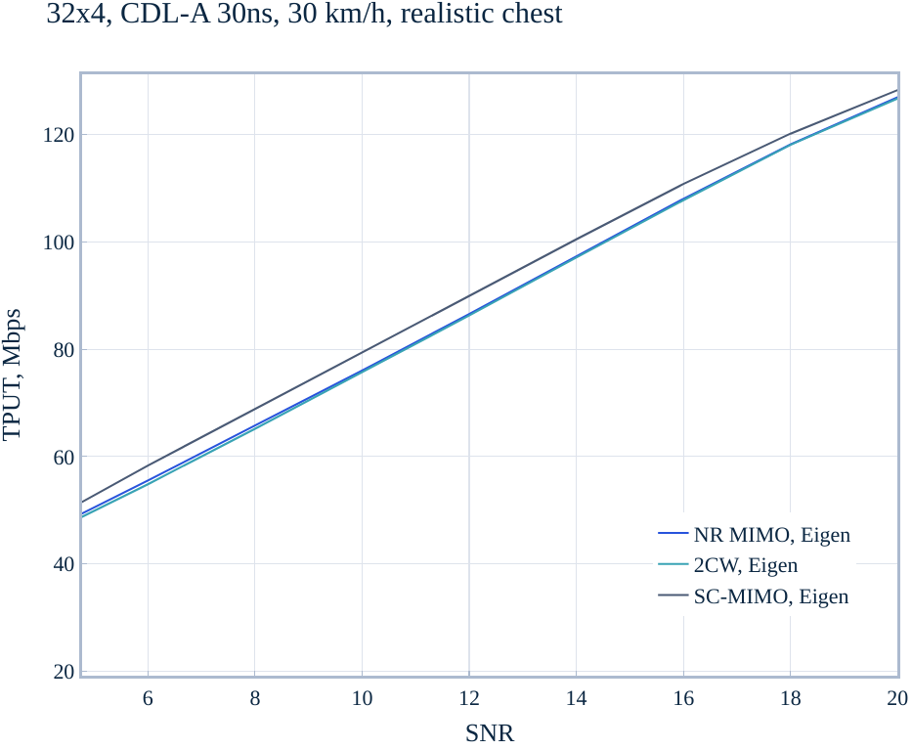
Figure 17. Rank 2 performance
The results for rank-4 transmissions are provided at Figure 18. In this case, layer imbalance becomes more noticeable. For 3 km/h scenario, both two-codeword transmission and SC-MIMO demonstrates comparable performance by leveraging on different per-codeword MCS and suppressing inter-layer interference, respectively. However, for 30km/h the interference becomes a bigger factor than the layer imbalance and SC-MIMO demonstrates superior performance with more than 1dB gain over NR baseline.

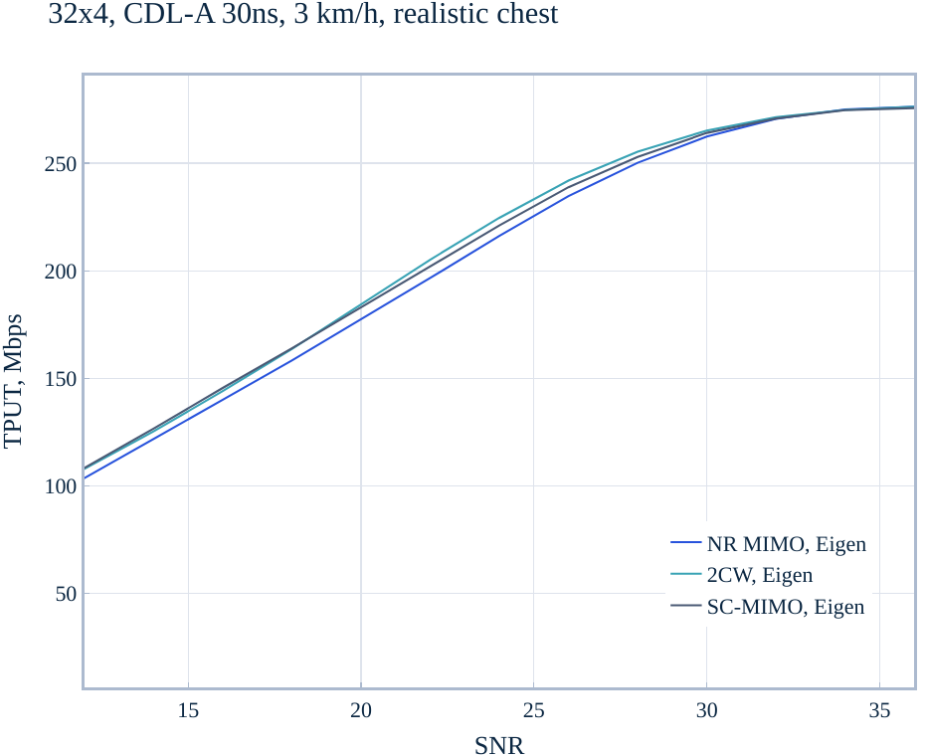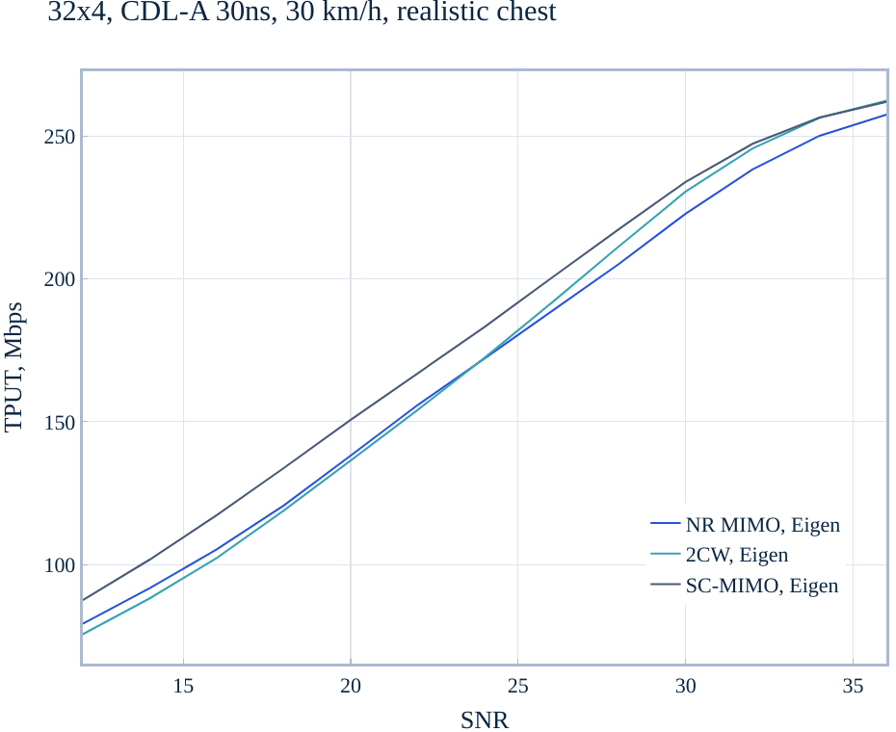
Figure 18. Rank 4 performance

Observation 9: Layer imbalance for rank-2 is too small to affect single-codeword transmissions
Observation 10: Suppressing inter-layer interference provides robust gains in all cases, including layer imbalance
Observation 11: SC-MIMO mapping provides robust performance gains over NR mapping across various transmission scenarios
Some of the performance gains provided by SC-MIMO can be obtained by using two-codeword transmissions. However, this approach has the following complications:
- Two separate HARQ processes with MCS/NDI/RVID value for each codeword need to be maintained at both network and UE sides, increasing modem control logic overhead substantially
- Extra signalling overhead due to more ACK/NACK messages, which may impact DL throughput due to overall worse link budget in uplink transmission. In addition, extra DCI overhead is needed to signal the scheduling information associated with each codeword
- Link adaptation becomes dependent on the receiver SIC capability. For example, setting equal BLER targets for each CW leads to receiver inability to leverage on its inter-CW SIC capability. Even SIC capable UEs may not be able to benefit the SIC performance if network configures both TBs to have the same outer-loop 10% BLER target. In addition, even if the NW configures proper BLER targets for the two CWs, this may not be achievable for scenarios with bursty traffic
To illustrate the second bullet point, Figure 19 demonstrates the estimated DL throughout impact for n77 band based on the PDSCH discard rates collected in the field. Transmitting two TBs instead of one leads to the loss in DL throughput.
Note that a single-codeword approach does not suffer from these issues and thus is much simpler to configure.
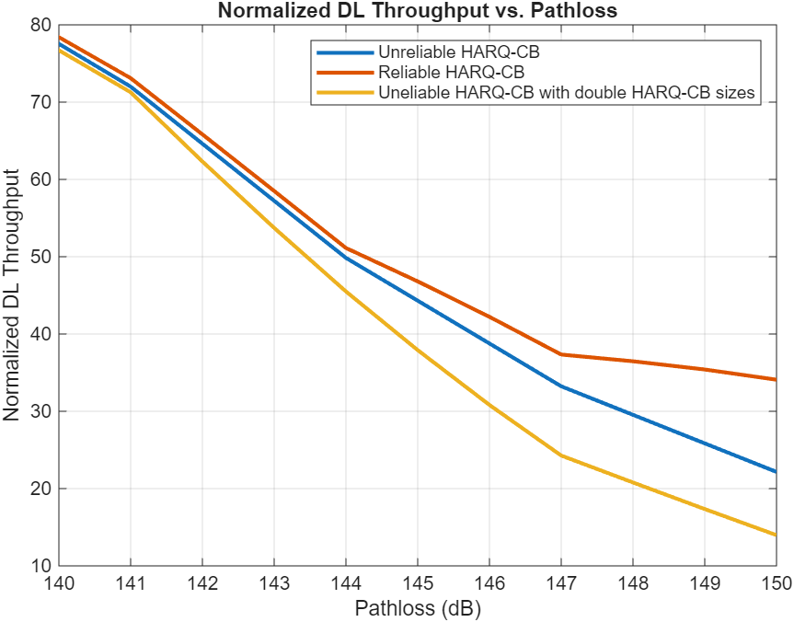
Figure 19. Impact of doubling ACK/NACK bits

Proposal 4: Support single-codeword transmission for downlink MIMO
Proposal 5: Study SC-MIMO layer mapping for 6G

Potential MIMO transmission mapping to close BICM capacity to Shannon
After soft-output MIMO detection, the detector returns bit LLRs that are fed to an LDPC decoder. These LLRs are typically assumed to be uncorrelated, whereas the spatial layers, in fact, remain correlated. Marginalizing bit-level LLRs in MIMO detector becomes the key source of the BICM capacity loss in MIMO channels, relative to the Shannon capacity. The BICM capacity loss can be substantial, especially when the number of MIMO layers grow large.
If the MIMO transmission mapping could enable the receiver to exploit mutual information across spatial layers while retaining low demod processing complexity, the BICM loss might be significantly reduced and hence the MIMO performance could be improved substantially.
Proposal 6: Study MIMO transmission schemes to reduce BICM capacity loss w.r.t. Shannon limit.

Successive Layer Mapping (SLM) precoding
As discussed in Section 3.3, one source of the BICM loss in MIMO channels is that the detector typically outputs bit-level LLRs only after marginalization, while the transmitted layers remain coupled through the MIMO channel. This suggests that part of the dependency naturally present across layers and resource positions is not preserved up to the stage of bitwise soft-information generation. The proposed approach was motivated in part by classical structured space-time transmission ideas, including the Alamouti transmit diversity scheme and the linear-dispersion framework of Hassibi and Hochwald, which showed that carefully designed mappings across antennas, layers, and time/resource positions can improve how the receiver exploits the structure of the transmitted signal.
The proposed Successive Layer Mapping (SLM) is therefore introduced as a precoding and modulation-mapping method applied on top of the baseline NR LDPC and QAM processing. In particular, the baseline LDPC coding, rate matching, HARQ operation, and bit interleaving remain unchanged. The only modification is a new SLM precoding operation that maps the coded bits into modulation symbols over an ordered sequence of layer/resource positions, together with a corresponding soft-output detector at the receiver. Hence, the proposal is a new transmission precoding/mapping structure intended to improve the practical MIMO operating point relative to conventional bitwise demapping.

High-level transmitter and receiver structure
A high-level block diagram of the proposed SLM scheme is shown in Figure 20.
At the transmitter, the information bits are first processed using the baseline NR LDPC coding chain. The resulting coded bits are then input to the SLM precoder, which generates one complex modulation symbol for each ordered transmission position. The ordered transmission positions may correspond to an ordered sequence across the spatial layers. The generated modulation symbols are then mapped to the corresponding spatial layer/resource positions and transmitted over the MIMO channel.
At the receiver, the received signal is first processed using the conventional channel estimation and per-resource preprocessing steps. A corresponding SLM detector then performs structured hypothesis evaluation over the ordered transmission positions and generates soft bit information. This can be done with simple modifications to the existing rML receiver, as we will explain later. The resulting bit LLRs are finally fed to the baseline LDPC decoder.
Accordingly, compared to the conventional NR chain, the proposed scheme introduces:
- A new SLM precoder at the transmitter; and
- A corresponding SLM detector at the receiver.
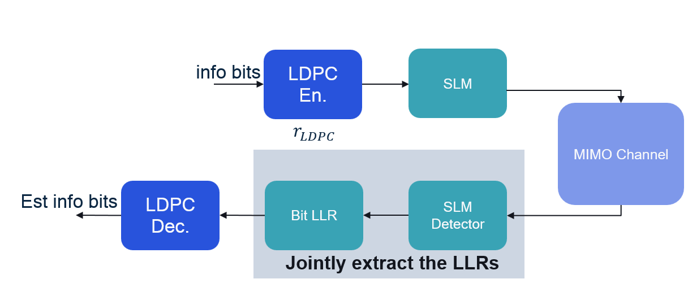
Figure 20. High-level transmitter and receiver structure of the proposed Successive Layer Mapping (SLM). Note that, the modulation is performed inside the SLM block. However, the modulation mapping is still the conventional square QAM.

Transmitter-side SLM precoding
To support structured detection with practical complexity, the proposed SLM precoder uses a symbol-domain superposition mapping that generates super-imposed symbols successively across multiple MIMO layers. Consider a sequence of coded bits of length $L×k$, where $L$ denotes the number of spatial layers, and $k$ denotes the number coded bits per layer. Denote these bits as [$u_{0},u_{1},…,u_{L-1}$], where each $u_{i}$comprises $k$ coded bits.
Under this mapping, the transmitted symbol in Layer $i∈\{0,1,…,L-1\}$ is formed by a superposition of two components:
- a first component $v(u_{i})$, determined by modulating current $k$-bit group $u_{i}$ using the conventional square QAM of order $2^{k}$; and
- a second component $a(p_{i-1})$, determined from the preceding transmission position.
Here, $p_{i-1}∈\{0,1\}^{Q_{m}-k}$denote $Q_{m}-k$ bits generated at the preceding transmission position. In particular, $p_{i-1}$ are generated based on the partial sequence [$u_{0},…,u_{i-1}$] via a function $h(⋅)$. The function $h(⋅)$ combines the information transmitted in the preceding position into $Q_{m}-k$ output bits. An example $h(⋅)$ can be found in the appendix.
According to the symbol-domain construction shown in Figure 21, the first transmitted symbol is given by
$$\begin{matrix} & x(1)=v(u_{1}) & & \text{(3.3-6a)}\end{matrix}$$
and, for $i=2,…,N$, the transmitted symbol is given by
$$\begin{matrix} & x(i)=a(p_{i-1})+v(u_{i}). & & \text{(3.3-6b)}\end{matrix}$$
Accordingly, the transmitted symbol at position $i$ is formed by superimposing $a(p_{i-1})$ with $v\left(u_{i}\right).$
When both $a(p_{i-1})$ and $v\left(u_{i}\right)$ are selected as square QAM, the resulting signal $x(i)$ is will still be a square QAM, as long as $a(p_{i-1})$ and $v\left(u_{i}\right)$ are scaled properly. Furthermore, the transmitted signal may be decoupled into its in-phase (I) and quadrature components (Q), where the super-position occurs separately across the I/Q dimension. This ensures that the demapper can operate on the I/Q dimension separately, thereby reducing the demodulation complexity significantly.
Furthermore, as will become clearly shortly, the recursive structure shown in Figure 21 works smoothly with practical rML demodulator, such as a sphere decoder or a list detector.
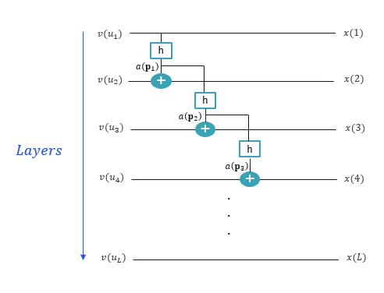
Figure 21. Successive symbol construction in the SLM precoder

Receiver-side SLM detector
At the receiver, the proposed SLM detector performs a tree search over the ordered transmission positions and generates soft bit information prior to LDPC decoding. The receiver processing is applied across the MIMO layers.
At a high level, the receiver first performs conventional channel estimation and obtains, for each resource element (RE), the received vector and the channel matrix. A QR decomposition is then applied per RE in order to transform the detection problem into an upper-triangular form. Based on the QR-transformed observations, the detector performs a successive layer search using the SLM structure and retains a limited number of low-metric candidate paths. The resulting candidate list is then used to generate bit LLRs for the baseline LDPC decoder.
Accordingly, the receiver-side processing consists of:
- QR preprocessing per RE,
- successive tree search via list/sphere decoder
- LLR extraction from the retained list, and
- baseline LDPC decoding.
Next, we provide the details on how the detector is performed.
Consider one RE and let $y∈C^{N_{r}×1}$denote the received vector, $H∈C^{N_{r}×L}$denote the effective channel matrix, both y and H are whitened and $x∈C^{L×1}$ denotes the transmitted signal. After applying the QR decomposition on $H$, we get an equivalent received signal
$$\begin{matrix} & \tilde{y}=Q^{H}y=Rx+\tilde{n} & & \text{(3.3-13)}\end{matrix}$$
where $\tilde{n}=Q^{H}n$ denote the effective noise, and $H=QR.$
The upper-triangular structure of $R$enables a successive search over the ordered transmission positions (or search levels), which in practice correspond to the ordered layers/resource positions used by the SLM precoder.
Let $i$denote the search level associated with an ordered transmission position.
In accordance with the TX-side notation, the first symbol hypothesis is written as
$$\begin{matrix} & x(1)=v(u_{1}) & & \text{(3.3-14a)}\end{matrix}$$
and, for $i=2,…,L$,
$$\begin{matrix} & x(i)=a(p_{i-1})+v(u_{i}). & & \text{(3.3-14b)}\end{matrix}$$
At the detector, the inherited anchor-selection bits $p_{i-1}$are determined by the current candidate path [$u_{0},…,u_{i-1}$], and therefore the candidate expansion at level $i$ is restricted to the $2^{k}$symbols associated with the allowed values of $u_{i}$ i.e., $l=0,2,..,2^{k}-1$. Hence, compared to a conventional search over the full $2^{Q_{m}}$-point constellation, the SLM detector only expands $2^{k}$candidates per layer, and the portion $a(p_{i-1})$ is determined from the current candidate path [$u_{0},…,u_{i-1}$] by construction.
Using the QR-transformed system in (3.3-13), the incremental distance metric at search level $i$may be written as
$$\begin{matrix} & d_{i}^{\left(l\right)}={\left|{\tilde{y}}_{i}-\sum_{j=i}^{N_{L}}{R_{i,j}}{\hat{x}}^{\left(l\right)}\left(j\right)\right|}^{2} & & \text{(3.3-16)}\end{matrix}$$
where ${\hat{x}}^{\left(l\right)}(j)$ denotes the symbol hypothesis along the candidate path, and the distance metric is accumulated across layers.
In order to reduce the number of hypotheses maintained by the detector, one needs to prune the search tree as the detector moves across the MIMO layers. This can be done in the same way as in conventional tree-search based rML detector. The detailed tree search strategies are up to receiver implementation.
Finally, after the tree search is completed, the retained candidate paths are used to generate bit LLRs for the LDPC decoder. Let $L$ denote the final retained list of candidate paths and let $D(λ)$ denote the final accumulated metric associated with candidate path $λ∈L$. For a coded bit $b_{t}$, a max-log LLR may be written as
$$\begin{matrix} & L(b_{t})≈\underset{λ∈L:b_{t}(λ)=0}{min⁡}D(λ)-\underset{λ∈L:b_{t}(λ)=1}{min⁡}D(λ). & & \text{(3.3-19)}\end{matrix}$$
In summary, compared to conventional symbol-by-symbol bitwise demapping, the proposed SLM detector exploits the structured dependency across the transmission layers during the tree search and only converts the result into bit-level LLRs after the structured detection step.

Link level performance evaluations
To assess the performance of the proposed SLM scheme under realistic propagation conditions, we perform evaluations over CDL channel models with 100 ns delay spread. The simulation setup assumes a downlink scenario with 32 TxRU at the transmitter and 8 Rx antennas at the receiver, with a carrier frequency of 7 GHz and a subcarrier spacing of 30 kHz. The MIMO antenna configuration is taken according to the EVM agreements. The resource allocation spans 20 PRBs. Closed-loop SVD based MIMO precoding is performed based on SRS measurements, with the precoder updated every 40 slots. Link adaptation is performed using Outer Loop Link Adaptation (OLLA), targeting a transport block BLER of 10%. The proposed 8-layer SLM is compared against the 5G NR baseline with link adaptation over 8/7/6/5 layers.
For NR, we used 2 codewords with rML receiver. For SLM, 1 CW is used across 8 layers, using the demodulator discussed in earlier section. For all schemes evaluated, we used realistic channel and interference/noise estimation in the downlink, and realistic SRS channel estimation in the uplink.
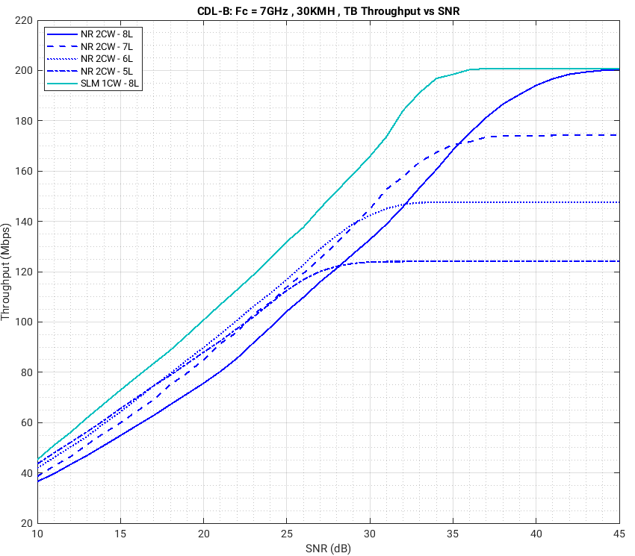
Figure 22. Throughput vs. SNR, CDL-B, 32TX × 8RX, 8-layer SLM vs. NR baseline (8/7/6/5 layers), SRS-based closed-loop MIMO, 20 PRBs, SCS 30 kHz, $f_{c}$ = 7 GHz, $v$ = 30 km/h, realistic channel estimation.

Figure 22 presents the throughput performance under a CDL-B channel model at a UE velocity of 30 km/h. The CDL-B profile captures a rich scattering environment with moderate delay spread, representative of typical urban NLOS conditions. At 30 km/h, the channel exhibits moderate Doppler variation relative to the 40-slot SRS-based precoder update period, introducing a degree of precoder mismatch that is typical for mobile UEs. In this scenario, the proposed 8-layer SLM consistently outperforms the NR baseline across the evaluated SNR range, demonstrating robustness to both channel estimation imperfections and precoder aging effects. The proposed SLM achieves approximately 1–7 dB SNR gain over the NR baseline across the evaluated throughput range under CDL-B at 30 km/h.
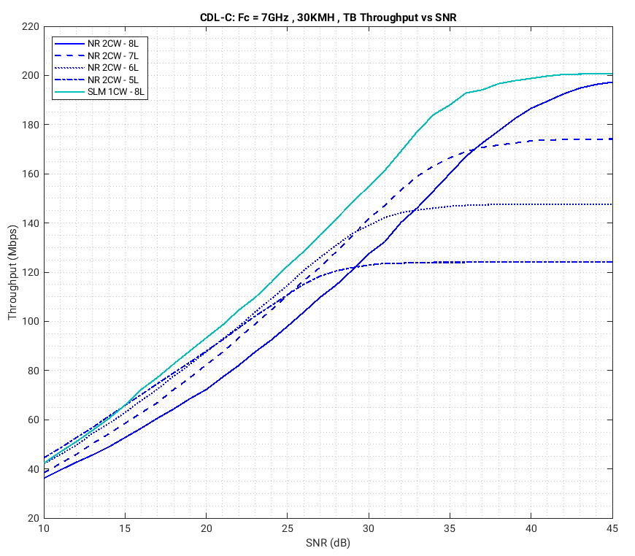
Figure 23. Throughput vs. SNR, CDL-C, 32TX × 8RX, 8-layer SLM vs. NR baseline (8/7/6/5 layers), SRS-based closed-loop MIMO, 20 PRBs, SCS 30 kHz, $f_{c}$ = 7 GHz, $v$ = 30 km/h, realistic channel estimation.

Figure 23 presents the throughput performance under a CDL-C channel model at a UE velocity of 30 km/h. CDL-C is characterized by a larger delay spread compared to CDL-B, representing a more frequency-selective channel with stronger and more spread-out multipath components. This richer multipath structure increases inter-layer interference, which the SLM receiver is specifically designed to exploit through its structured tree-search detection over the QR-decomposed channel. Under these more demanding propagation conditions, the proposed 8-layer SLM continues to deliver meaningful gains over the NR baseline, confirming that the SLM detection framework effectively leverages the additional frequency selectivity present in the CDL-C profile. The proposed SLM achieves up to 6 dB SNR gain over the NR baseline in the 8L regime under CDL-C at 30 km/h.
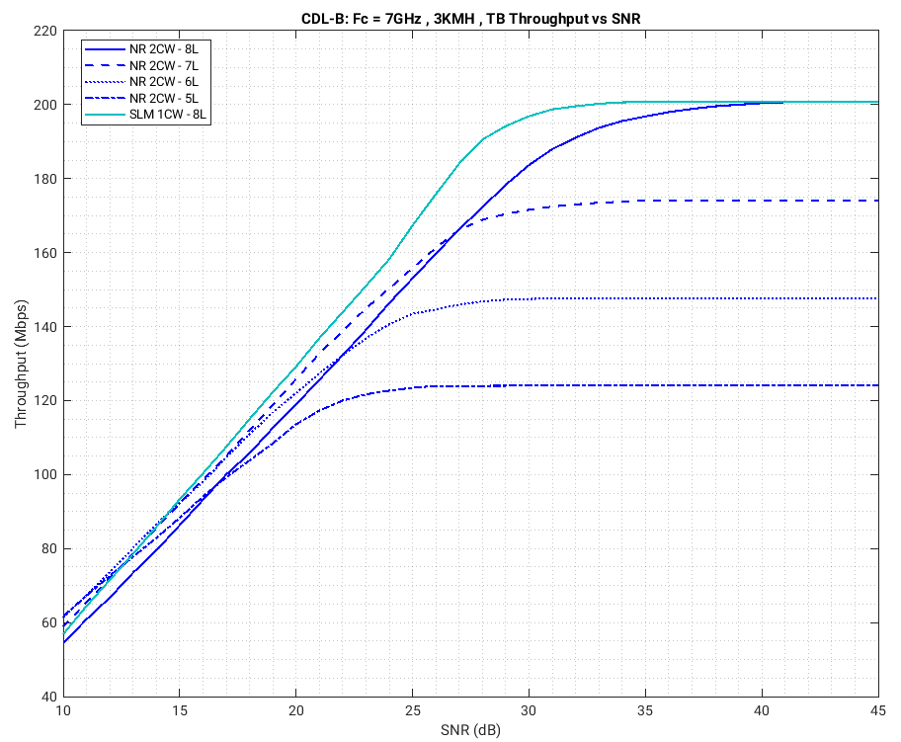
Figure 24. Throughput vs. SNR, CDL-B, 32TX × 8RX, 8-layer SLM vs. NR baseline (8/7/6/5 layers), SRS-based closed-loop MIMO, 20 PRBs, SCS 30 kHz, $f_{c}$ = 7 GHz, $v$ = 3 km/h, realistic channel estimation.

Figure 24 presents the throughput performance under a CDL-B channel model at a reduced UE velocity of 3 km/h. At this near-static mobility, the Doppler spread is minimal and the channel varies negligibly over the 40-slot SRS-based precoder update interval, resulting in a well-maintained alignment between the SRS-derived precoder and the instantaneous channel throughout the scheduling horizon. Correspondingly, the interlayer interference is smaller compared to the 30Km/h scenario. As a result, the performance gains of SLM over the NR baseline gets smaller. Yet still, SLM achieves up to 4 dB SNR gain over the NR baseline across the evaluated throughput range under CDL-B at 3 km/h.

DMRS enhancements for PDSCH
DMRS supports the channel estimation and demodulation of PDSCH. The key areas for DMRS enhancements are channel estimation quality under diverse types of channels and reducing system overhead. Obviously with larger delay spread, the channel is more frequency selective and higher frequency domain DMRS density is needed. With higher Doppler, the channel is more selective in time and higher time domain DMRS density is needed. In this section, we provide our view on possible DMRS enhancements for PDSCH, with focus on
- Basic DMRS pattern as a function of Doppler and delay spread
- Possible DMRS overhead reduction in time domain and frequency domain

Doppler and delay spread dependent DMRS pattern

Time domain pattern
In the RAN1-124b, we have the following agreements
Agreement
- For TDRA for PDSCH:
  - Support a single mapping type, at least for PDSCH within a single slot
    - Support flexible starting symbol
      - Study which symbol(s) can be the starting symbol
    - Study number of symbols
      - Granularity is 1 symbol
    - Further study DMRS position(s)
    - Study time offset from the scheduling PDCCH, considering UE processing capabilities
  - Study whether/how to support a single PDSCH transmission crossing slot boundary
    - Including the maximum PDSCH duration
    - Including whether the single PDSCH transmission can occupy contiguous or non-contiguous symbols
    - Including impact on performance and complexity
    - Including maximum TB size limit
    - Note: If cross-slot boundary PDSCH transmission is supported, a single mapping type is supported also for cross-slot PDSCH transmission
  - Study whether/how to support PDSCH repetition

As in NR, multiple instances of DMRS in time within a PDSCH is to handle time varying channel due to Doppler. The set of patterns and corresponding density of the DMRS in time is optimized for the Doppler range we expect to see. In this subsection, we provide our view on the time domain patterns for 6GR DMRS in PDSCH.
Before we design time domain DMRS pattern for PDSCH, we need to know how long a PDSCH can be.
In 5G-NR, slot is not only a time unit, but also a scheduling unit. In Rel.15, per slot scheduling was designed first and mini-slot scheduling was added for URLLC and slot-aggregation was added later for coverage extension. In 6GR, for simplicity of the design, it is preferred to support a more flexible time domain structure for PDSCH starting from the beginning. In other words, the PDSCH length can be more flexible (instead of restricted to be within a slot) and PDSCH can cross the slot boundary. This can help solving multiple problems, including better DMRS overhead and performance trade-off and more efficient DCI usage when more resources can be granted with a single DCI.
Additionally, currently with a TDD pattern with S slots, the D symbols in the S slot are typically harder to use or have worse performance for data transmission in D slots, as the SLIV is typically shorter in S slots (larger DMRS overhead or lower DMRS density in time). If we allow PDSCH to cross slot boundary, we can merge the D symbols in S slot with previous D symbols in D slot and share DMRS to achieve better performance.
Proposal 7: For 6GR, support PDSCH designs crossing slot boundaries.
For data channel in NR, DMRS time domain pattern is designed per slot, with a few choices on number of looks in time to handle different target Doppler range. As Doppler increases, the DMRS overhead increases quickly. For 6GR, we believe there is room for improvement on DMRS time domain density to optimize for the trade-off between Doppler and overhead.
Long SLIV (start and length indicator) is proposed in our earlier paper to natively support coverage extension and improve the resource allocation efficiency, by allowing time allocation to cross the slot boundary. With a longer SLIV, there is room for DMRS overhead reduction, as we can design a time domain DMRS pattern per SLIV instead of a slot where one can uniformly spread out the DMRS symbols across the entire slot and the time domain density S will depend on the Doppler. As shown in Figure 25, the DMRS symbols are spaced out over the entire long SLIV with S symbol gap with front and rear gap being B and A symbols. For different Doppler frequencies, we can have different choices of S, regardless of the length of the SLIV, if it is longer than some threshold. We perform a simulation to illustrate the optimal S symbol gap values for different Doppler frequencies, with 100MHz rank-2 two-slot long PDSCH transmission under 256T4R CDL-B 100ns channel which is shown in Figure 26. The optimal symbol separation S trading off DMRS overhead and Doppler is shown by the ‘cyan’ line in Figure 26.
For a given SLIV, the maximum rear/front extrapolation length (A,B) can also be optimized based on Doppler and SLIV length. We can study how to define uniform time domain DMRS patterns with parameters (S, A, B) for different Doppler to reduce the DMRS overhead while limiting the number of DMRS patterns handled by UE receiver.
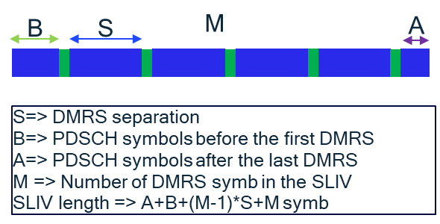
Figure 25. Notation for DMRS pattern in time domain
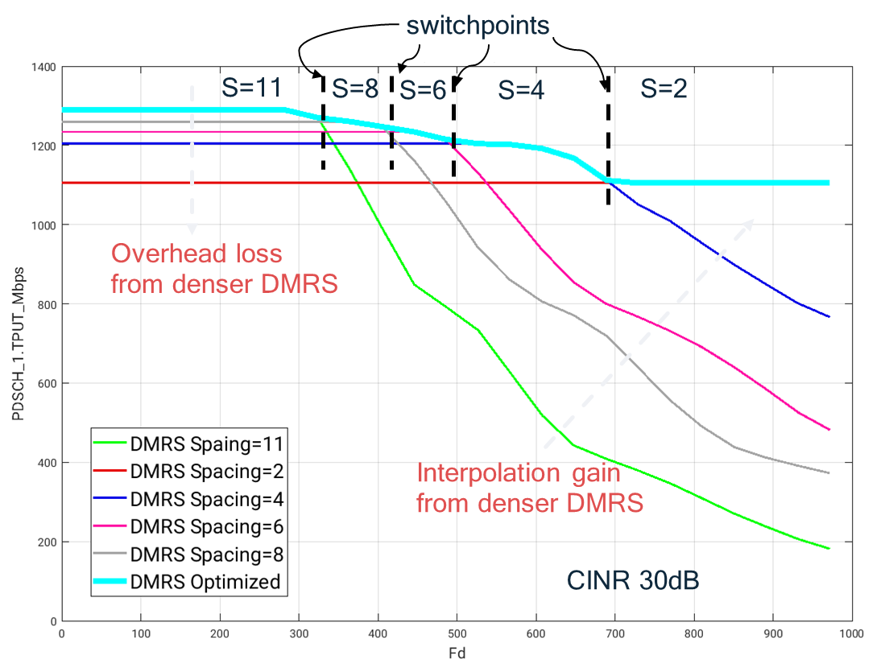
Figure 26. Optimal DMRS separation for different Doppler frequencies for 2-slot SLIV
Proposal 8: Study the design of almost uniform DMRS time domain pattern with different target Doppler for SLIVs longer than a slot
In 5G NR, the 1st DMRS symbol location and the location and number of remaining DMRS symbols for a given SLIV length is RRC configured. But due to UE mobility, the Doppler frequencies may change over time and we may want to adjust the DMRS time domain density more dynamically to reduce DMRS overhead. Additionally, when MU-MIMO is used to serve multiple UEs in FDM fashion, we will need to align the DMRS locations across these UEs. Allow more dynamic control of the DMRS time domain density (e.g. with DCI) will allow more flexible pairing of UEs with different moving speed.
Proposal 9: Study how to dynamically indicate the DMRS time domain density
For the UE receiver, good Rnn estimation quality is essential in building a high quality equalizer for better performance. In NR design, type A PDSCH DMRS pattern was introduced, so the first DMRS location is fixed (at symbol 2 or symbol 3 of a slot), so that the Rnn estimation quality can be improved. However, in NR, there are a lot of DMRS patterns whose usage depend on the RRC setting of different UEs and the SLIV of each PDSCH. This complicates the UE implementation and the Rnn estimation quality for later DMRS in a slot is still problematic.
For 6GR, we would like to consider a more aligned DMRS time domain pattern as enhancement to NR type A PDSCH. Instead of aligning the first DMRS symbol only, when more DMRS symbols are used, they should appear is more deterministic locations as well. For example, the first DMRS is in symbol 2, while later DMRS symbols are in symbol 7 and symbol 12 in the slot. This is illustrated in Figure 27.

Figure 27. Fixed DMRS patterns in a 14-symbol slot (yellow- PDSCH, brown- DMRS)
With DMRS in symbol 2/7/12, a natural question is whether we can handle very high Doppler channel. In Figure 28, we evaluated the performance of this fixed DMRS pattern as a function of Doppler (at a centre frequency of 7Gz, 1000Hz Doppler translates to a speed of about150 Km/h) and compared with legacy NR 4 DMRS per slot pattern. CINR of 15dB, 25dB, and 35dB are shown. As expected, we can observe a throughput cross as CINR increases with 3 DMRS looks pattern being better at lower Doppler due to lower overhead and 4 DMRS pattern being better at higher Doppler. The cross over points decreases with higher CINR. It can be seen that at very high CINR of 35dB, the cross over point is about 950 Hz (~ 147 km/h). For very high speed scenario, a denser DMRS in time domain might be needed. However, in that speed range, we typically see a Doppler shift instead of a Doppler spread and some other techniques other than brute force increase DMRS overhead may be more efficient in improving the channel estimation, such as PT-RS.
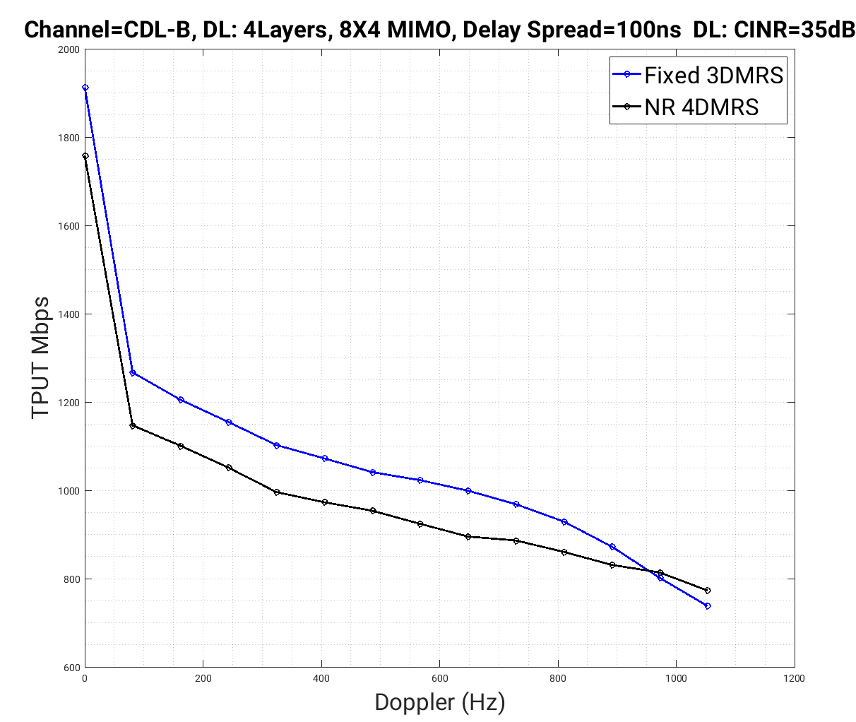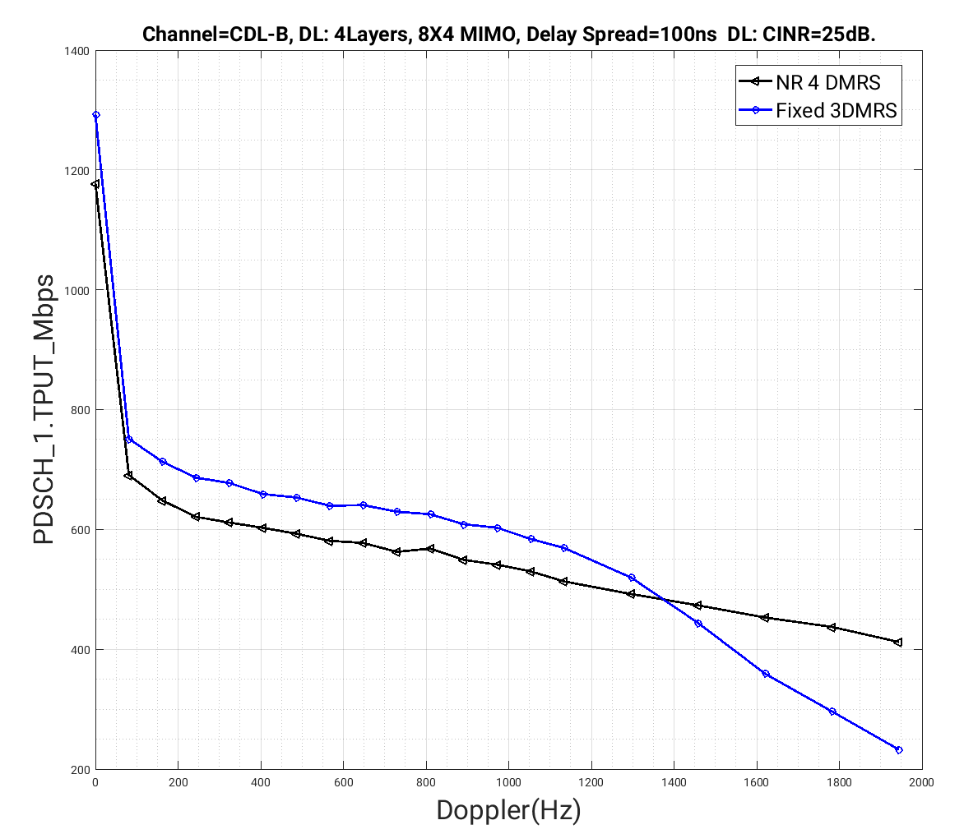

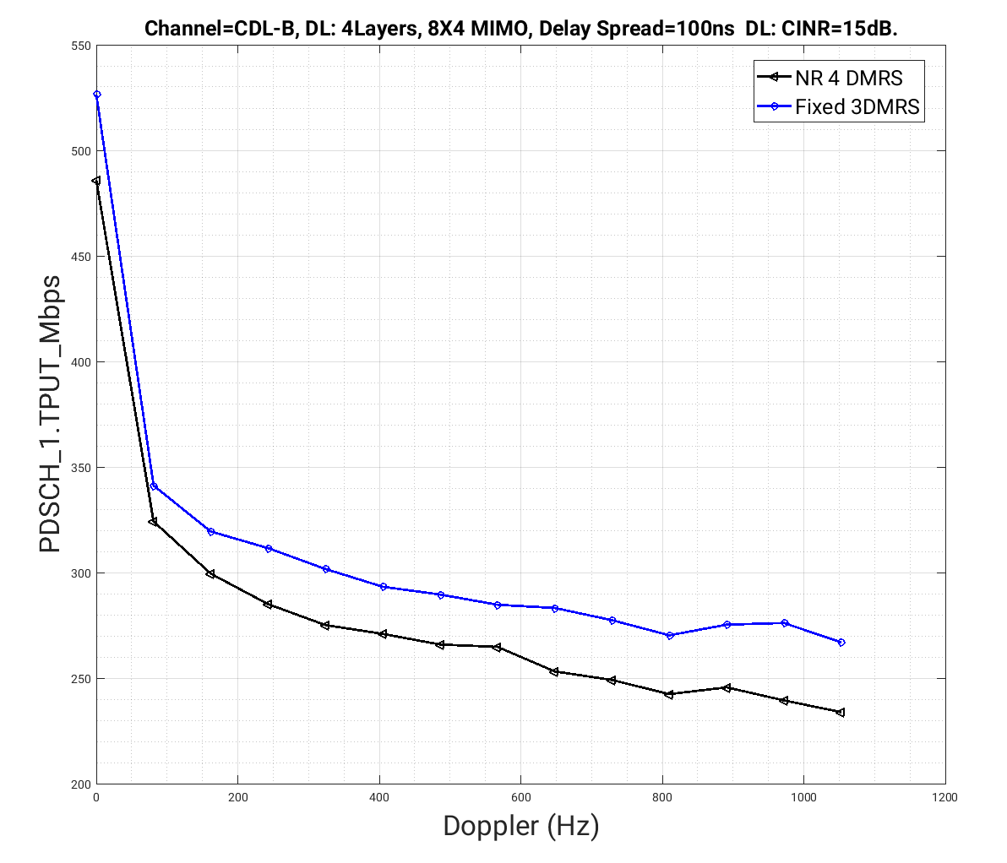
Figure 28. Performance comparison of fixed DMRS pattern at CINR=35dB, 25dB, 15dB
Proposal 10: Study enhanced PxSCH with fixed time domain DMRS candidate locations such as 2/7/12 and potentially remove 4 DMRS looks per slot pattern.
With the fixed DMRS candidate locations, we can also limit the number of SLIV patterns. Assuming a SLIV needs to contain at least one DMRS symbols, the SLIV starting symbol need to start before/at the symbol 2/7/12 and the entire SLIV needs to cover at least one DMRS symbol.
Proposal 11: The PxSCH only supports SLIV patterns which cover at least one DMRS symbol from the fixed candidate locations, e.g. 2/7/12

The maximum number of orthogonal DMRS ports
In RAN1 124 agreement, we have agreed to study the maximum number of orthogonal DMRS ports.
Agreement
- Study the following options regarding the spec impact on the maximum number of orthogonal DMRS ports for PDSCH
  - Option 1: Up to 24 orthogonal DMRS ports
  - Option 2: Up to 32 orthogonal DMRS ports
  - Option 3: Up to 48 orthogonal DMRS ports
  - Option 4: Up to 64 orthogonal DMRS ports
  - Option 5: Up to 96 orthogonal DMRS ports
- Study Non-orthogonal DMRS on top of the options above to achieve the target number of MIMO layers (from network side)
- Note: To provide link/system level simulation results for this study

To study the maximum number of orthogonal DMRS ports needed, e.g., 24/32/48/64/96, it is necessary to assess the end-to-end system level performance in the high-rank transmission scenario under realistic deployments. To support a given number of MIMO layers, relying on either a set of fully orthogonal DMRS ports or a combination of orthogonal and nonorthogonal DMRS ports is possible. For example, to support 96-UE MU-MIMO transmission with single-layer transmission for each UE, either 96 orthogonal DMRS ports (e.g., comb-2 + FD-OCC 24 + TD-OCC 2) or 4 nonorthogonal DMRS ports imposed on top of 24 orthogonal DMRS ports (e.g., comb-2 + FD-OCC 12) would be possible. Then, the question is how many orthogonal DMRS ports would deliver the best system level performance in the end.
The main benefit of employing a large number of orthogonal DMRS ports is the reduction in the inter-port interference, which may lead to improved DMRS channel estimation performance. However, such a gain may not always be realized in practice due to various factors such as the channel profile, DMRS overhead, etc. To accommodate a large number of orthogonal DMRS ports, either the (1) CDM group number should be increased by reducing the DMRS frequency density, e.g., from comb-2 to comb-4, (2) FD-OCC should be increased, and/or (3) TD-OCC should be increased. However, increasing each dimension leads to certain degradation in the DMRS channel estimation performance.
In particular, reducing the DMRS frequency density would lead to coarser frequency-domain channel estimation granularity. Likewise, increasing the FD-OCC may lead to unintended inter-port leakage among the “orthogonal” DMRS ports within the same CDM group when the delay spread is nonnegligible, which violates the main purpose of employing a large number of orthogonal DMRS ports. Also, higher TD-OCC would incur additional DMRS overhead, which would directly impact the DL throughput. Furthermore, it would be necessary to quantify how the gain offered by orthogonal DMRS ports translates to the overall system performance under presence of imperfect CSI, e.g., SRS channel estimation error, CSI aging due to the long sounding periodicity.
Proposal 12: Study the maximum number of orthogonal DMRS ports needed in the system level perspective taking into account the DMRS overhead, DMRS channel estimation performance dependent on the channel profile, and imperfect CSI.
The impact of the maximum number of orthogonal DMRS ports on the system level performance is evaluated for the single-cell massive MU-MIMO setup. The gNB with 1024 TxRUs (M, N, P, Mg, Ng; Mp, Np) = (4, 128, 2, 1, 1; 4, 128) simultaneously serves multiple UEs each with 4R (M, N, P, Mg, Ng; Mp, Np) = (1, 2, 2, 1, 1; 1, 2). Among 200 UEs dropped based on the UMi layout, at most 96 UEs are scheduled for DL. The SLR precoding is applied based on the SRS sounded every 20 ms. The UEs scheduled for MU-MIMO are SDMed on the 12-symbol PDSCH. Each UE is served with single-layer transmission, which involves DMRS channel estimation followed by MMSE combining. The co-scheduled UEs experience either the 10%-ile or 50%-ile UMi coupling loss, which translates to roughly 42 dB or 22 dB SNR. The details of the simulation are summarized in Table 3.
Table 3. System level simulation parameters for orthogonal DMRS port evaluation
Layout | (# cells, # UEs per cell, # active UEs per cell) = (1, 200, {24, 48, 96})
Carrier frequency | 8 GHz
BW | 20 MHz
SCS | 30 kHz
SNR | {22, 42} dB, i.e., roughly equivalent to {50, 10}%ile UMi coupling loss under 51 dBm TxP
gNB array | 1024 TxRUs with (M, N, P, Mg, Ng, Mp, Np) = (4, 128, 2, 1, 1; 4, 128)
UE array | 4R with (M, N, P, Mg, Ng, Mp, Np) = (1, 2, 2, 1, 1; 1, 2)
UE velocity | 3 km/h
Precoder | SLR
Combiner | MMSE
# layers per UE | 1
ChanEst | Realistic SRS with 20 ms periodicity and realistic DMRS ChanEst
# orthogonal ports | {12, 24, 48, 96}

To serve a given number of UEs, either a set of fully orthogonal DMRS ports or nonorthogonal DMRS ports imposed on top of the orthogonal DMRS ports are considered. For example, 96 UEs may be served with 96 orthogonal DMRS ports or 24 orthogonal DMRS ports combined with 4 nonorthogonal DMRS ports. To construct a given number of orthogonal DMRS ports, the following FD/TD-OCC setup is adopted as described in Table 4. The comb structure is always fixed to 2. When increasing the number of orthogonal DMRS ports, the tradeoff would be governed by the DMRS overhead and DMRS channel estimation performance. In particular, increasing the number of orthogonal DMRS ports would reduce the inter-port interference, while the frequency-domain granularity and time-domain overhead would decrease/increase due to the increased FD/TD-OCC.
Table 4. FD/TD-OCC setup for orthogonal DMRS port
# orthogonal DMRS ports | Comb/OCC | DMRS overhead (symbols)
12 | Comb 2, FD/TD-OCC 6/1 | 1
24 | Comb 2, FD/TD-OCC 12/1 | 1
48 | Comb 2, FD/TD-OCC 12/2 | 2
96 | Comb 2, FD/TD-OCC 24/2 | 2

To study the impact of the maximum number of orthogonal DMRS ports on the system level performance, the simulation results on the sum PDSCH throughput are shown in Figure 29 to Figure 33. For a given number of orthogonal DMRS ports, the tradeoff would be governed by the delay spread, SNR, and CSI aging. First, consider the ideal case in Figure 29 where the channel is nearly flat, i.e., 10 ns delay spread, SNR is extremely high, i.e., 42 dB, under the instantaneous CSI, i.e., perfect scheduling and SLR precoding. In such a case, using a large number of orthogonal DMRS ports that scale with the number of UEs is beneficial because it reduces the inter-port interference. Meanwhile, the impact of the reduced DMRS frequency density due to the large FD-OCC is negligible since the delay spread is low. Although a large number of orthogonal DMRS ports may increase the DMRS overhead, this price is rewarded by the increased throughput, making 48 or 96 orthogonal DMRS ports preferrable.
However, in the realistic case where the delay spread is not too small and/or SNR is not extremely high and/or CSI aging is nonnegligible as shown in Figure 30 to Figure 33, the gain offered by a large number of orthogonal DMRS ports is not that large, while the price to pay for accommodating a large number of orthogonal DMRS ports is expensive, e.g., increased DMRS overhead (TD-OCC), DMRS channel estimation performance degradation due to the increased frequency-domain DMRS density (FD-OCC). As a result, a moderate number of orthogonal DMRS ports, e.g., 24, would provide a balanced tradeoff, while 48 or 96 orthogonal DMRS ports would lead to overall system performance degradation due to the expensive price to pay.
In particular, in case the SNR is not extremely high as in Figure 30, the impact of the inter-port interference is comparable with thermal noise. Therefore, the inter-port interference mitigation offered by orthogonal DMRS ports provides little gain, while the price to pay for supporting a large number of DMRS ports would make extremely large number of orthogonal DMRS ports, e.g., 48/96, less preferred as evident from the poor sum PDSCH throughput. In a similar fashion, if there is CSI aging as in Figure 31 (10 ms, i.e., practical CSI aging) and 30 (1 ms, i.e., minimal CSI aging), the sum PDSCH throughput that can be supported by the system is already capped to some extent. In such a case, reducing the inter-port interference by increasing the number of orthogonal DMRS ports would offer little benefit due to the already capped system performance, while the increased DMRS overhead, reduced frequency DMRS density, etc., would negatively impact the overall performance. In case the delay spread is not unrealistically small as in Figure 33, even if the SNR is high and there is no CSI aging, employing a too-large number of orthogonal DMRS ports, e.g., 48/96, would lead to poor DMRS channel estimation performance due to the high FD-OCC level.
Observation 9: From our DL MU-MIMO simulations, more than 24 orthogonal DMRS ports does not help the network total throughput, considering channel estimation loss with larger FD-OCC, higher overhead with more orthogonal DMRS ports, realistic SRS delay, and typical SNR range.
Proposal 13: Support up to 24 orthogonal DMRS ports for PDSCH. Use non-orthogonal DMRS ports if more spatial layers are needed.
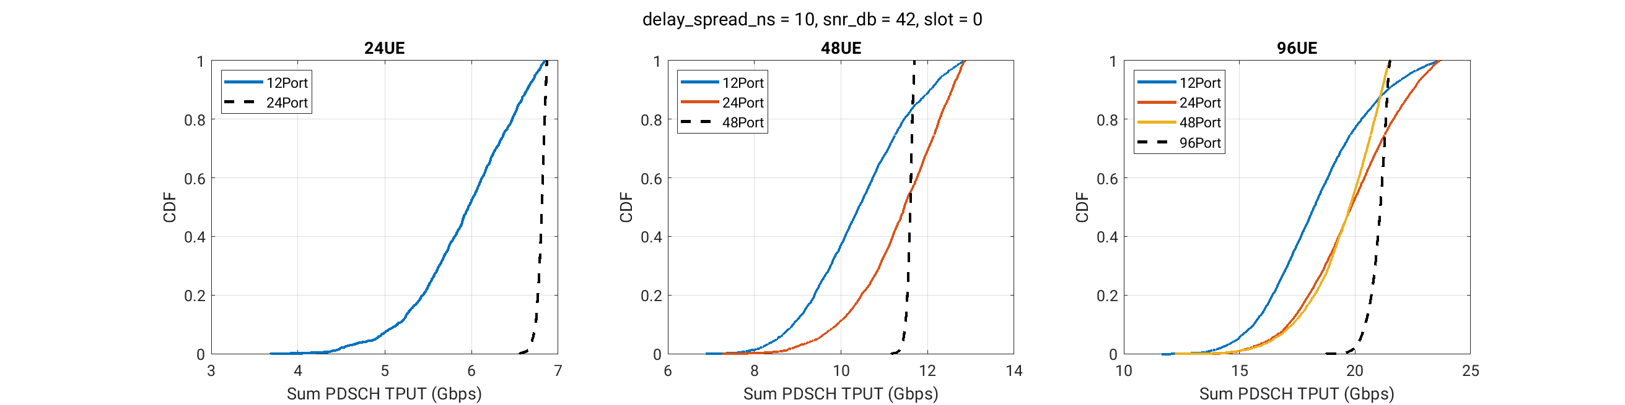
Figure 29. Sum PDSCH throughput under delay spread = 10 ns, SNR = 42 dB, instantaneous CSI
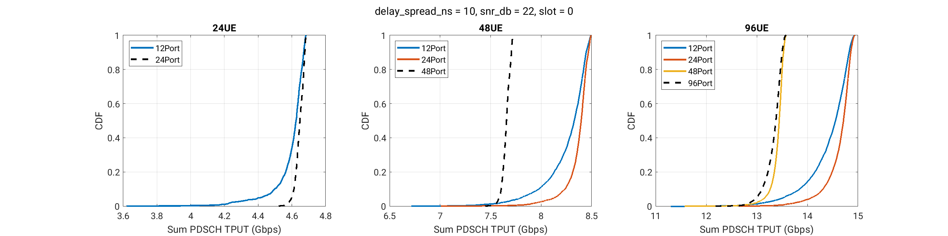
Figure 30. Sum PDSCH throughput under delay spread = 10 ns, SNR = 22 dB, instantaneous CSI
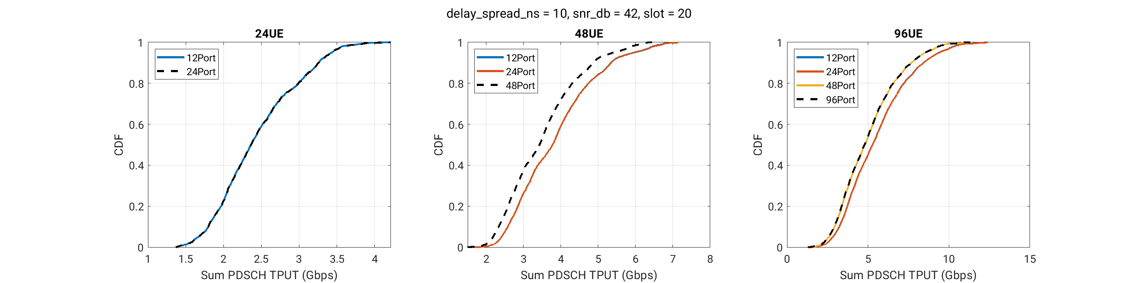
Figure 31. Sum PDSCH throughput under delay spread = 10 ns, SNR = 42 dB, CSI aging = 10 ms
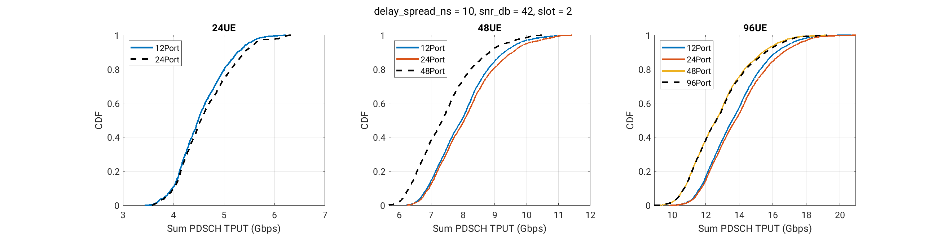
Figure 32. Sum PDSCH throughput under delay spread = 10 ns, SNR = 42 dB, CSI aging = 1 ms
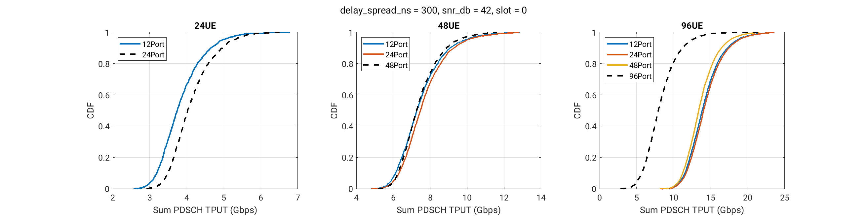
Figure 33. Sum PDSCH throughput under delay spread = 300 ns, SNR = 42 dB, instantaneous CSI

Frequency domain pattern
In RAN1-124b, the following DMRS pattern candidates are agreed,
Agreement
- For evaluation of DMRS for PDSCH, the following aspects are considered for further study:
  - Candidates for FD-OCC length: 2, 3, 4, 6, 8, 12, 16, 24, x
  - Candidates for TD-OCC length: 1 (i.e., single-symbol DMRS), 2, 4, x
  - Candidate for number of CDM groups: 2, 3, 4, 6, 8, 12, x
  - CDM group structure, e.g., comb-based, block-based, etc.

NR supports two DMRS configurations (type 1 & 2) with FD-OCC 2 and FD-OCC4. E-type-1/2 (with FD-OCC4) could support up 8/12 DMRS ports per DMRS symbol and 16/24 DMRS ports with TD-OCC2. Increasing the TD-OCC length for larger number of ports would greatly increase the DMRS overhead and impacts to the throughput (Tput) performance. Increasing the length of FD-OCC allows us to multiple more DMRS ports in a DMRS symbol and is a simple technique to reduce DMRS overhead. Depending on the delay spread of the channel, one can adjust the length of the FD-OCC for the DMRS efficiency. For lower delay spread scenario, one can go with even longer FD-OCC, e.g. FD-OCC8, to further reduce DMRS overhead.
For DMRS overhead saving, increasing the number of CDM groups (larger comb size) while fixing the FD-OCC allows more data REs to be FDM’ed in the DMRS symbol. But if the number of CDM groups is too large, the number of DMRS tones for noise/interference ($R_{nn}$) estimation and channel estimation can be greatly reduced. From our experiments, DMRS frequency density is preferred not to go beyond comb 4 and increasing the FD-OCC length is preferred if more DMRS ports are needed
To support >= DMRS 24 ports, it may be necessary to consider longer FD‑OCC lengths combined with a uniform comb structure (e.g., comb‑2 or comb-3 or comb‑4). Assuming the TD-OCC2 from NR can be applied, 24/48 DMRS ports would correspond to 12/24 DMRS ports per DMRS symbols.
To support 12 DMRS ports per DMRS symbol, we can introduce comb-3 structure and re-use the FD-OCC 4 from NR, where FD-OCC4 is constructed from nested Kronecker product of two $2×2$ Hadamard matrices
$$W_{4}=\left[\begin{matrix}1 & 1 \\ 1 & -1\end{matrix}\right]⊗\underset{W_{2}}{\underbrace{\left[\begin{matrix}1 & 1 \\ 1 & -1\end{matrix}\right]}}$$
To support 24 DMRS ports per DMRS symbol, we can introduce FD-OCC 8 which can be constructed using a nested construction as follows:
$W_{8}=W_{4}⊗\left[\begin{matrix}1 & 1 \\ 1 & -1\end{matrix}\right]=W_{2}⊗W_{2}⊗W_{2}=A⊗B⊗C$,
and apply to the comb‑3 DMRS waveform. The $2×2$ matrices $A=B=C=W_{2}=\left[\begin{matrix}1 & 1 \\ 1 & -1\end{matrix}\right]$ where $C$ is the inner code, $B$ is the 1st stage outer code, and $A$ is the 2nd stage outer code.
For supporting a higher number of DMRS ports per DMRS symbol (e.g., 12 or 24), multiple design options based on different combinations of CDM groups and FD‑OCC lengths are possible, as well as different DMRS tone grouping strategies (e.g., comb based or cluster/block‑based). It is therefore important to understand which options provide the best trade‑off between DMRS overhead savings and channel estimation performance.
We introduce the following DMRS frequency pattern notation for describing different DMRS patterns to be studied:
$$\left(X,Y,Z\right)=(\# of CDM groups, \# of cluster per CDM group, DMRS tones per cluster/block)$$
where $X×Y=FD-OCC length$. In Figure 34, the left subfigure illustrates a comb‑3 pattern with FD‑OCC4, while the right subfigure shows a cluster pattern with FD‑OCC4 (E-type-2). In the left example, X=3 CDM groups, Y=4 clusters per CDM group (to which FD‑OCC is applied), and Z=1 DMRS tone per cluster. In the right example, X=3 CDM groups, Y=2 clusters per CDM group, and Z=2 DMRS tones per cluster.
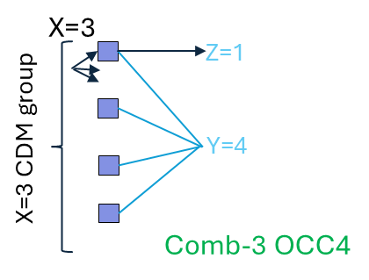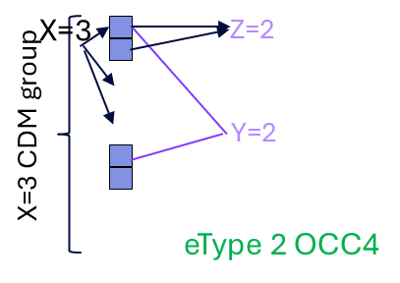
Figure 34. DMRS frequency pattern $(X,Y, Z)$
For 12 and 24 DMRS ports per DMRS symbol, simulations are conducted to evaluate different combinations of frequency‑domain DMRS patterns and FD‑OCC lengths, as summarized below:
12 ports per DMRS symbols | 24 ports per DMRS symbols
- (3,4,1): comb-3+FD-OCC4  - (6,2,1): comb-6+FD-OCC2  - (3,2,2): etype-2 (FD-OCC4, cluster based) | - (3,8,1): comb-3+FD-OCC8  - (4,6,1): comb-4+FD-OCC6  - (6,4,1): comb-6+FD-OCC4  - (6,2,2): 2 two-tone cluster+FD-OCC4  - (6,1,4): 1 four-tone cluster+FD-OCC4

The simulation assumes 32 TXRUs (M, N, P, Mg, Ng, Mp, Np) = (8, 8, 2, 1 ,1; 2, 8), (d_{H}, d_{V}) = (0.5, 0.8) at gNB, 4R (M, N, P, Mg, Ng; Mp, Np)=(1, 2, 2, 1, 1; 1, 2) at UE, 12 symbol PDSCH with 2 DMRS, Doppler=111Hz (30kmph @ 4GHz), 100MHz BW (272RBs), SCS=30Khz, SVD precoding and MMSE channel estimator. The DMRS ports are loaded up in one CDM group first and then across CDM groups, and PDSCH REs are FDMed in the DMRS symbols.
For the 12‑port case in Figure 35, comb‑3 + FD‑OCC4 outperforms eType‑2 and comb‑6 + FD‑OCC2 by approximately 1% and 5%, respectively, under 300 ns delay spread. Under 100 ns delay spread, comb‑3 + FD‑OCC4 shows a slight but consistent advantage over the other schemes for all CNR$s$.
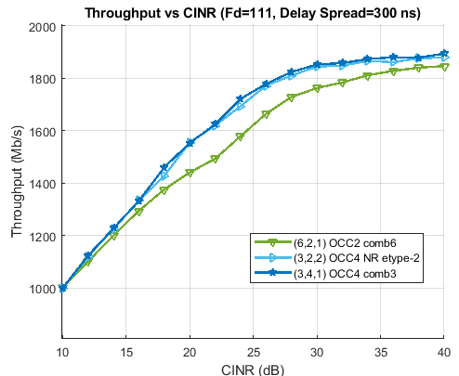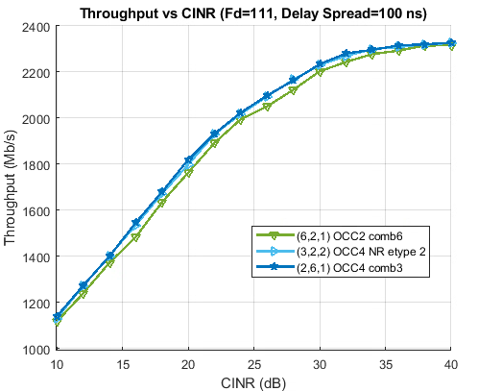
Figure 35. Tput for 12 ports per DMRS Symbol

Observation 10: For 12 ports per DMRS symbols pattern, FD-OCC 4 + comb 3 provides the most robust Tput performance compared to FD-OCC 2 + comb 6 and NR etype-2 (FD-OCC4)
Proposal 14: For 12 ports per DMRS symbol FD pattern, support FD-OCC length 4 with Comb-3
For the 24 ports case, the throughput results of different DMRS pattern and FD‑OCC combinations with rank adaptation from 1 to 4 are shown in Figure 36. The comb‑3 + FD‑OCC8 configuration significantly outperforms both comb‑4 + FD‑OCC6 and the cluster‑based pattern (type‑2 extension), achieving approximately 54% and 80% throughput gains, respectively, under 300 ns delay spread. Under 100 ns delay spread, the corresponding gains are approximately 5% and 16%. These results indicate that comb‑3 + FD‑OCC8 provides robust performance, particularly under medium‑to‑large delay spread conditions.

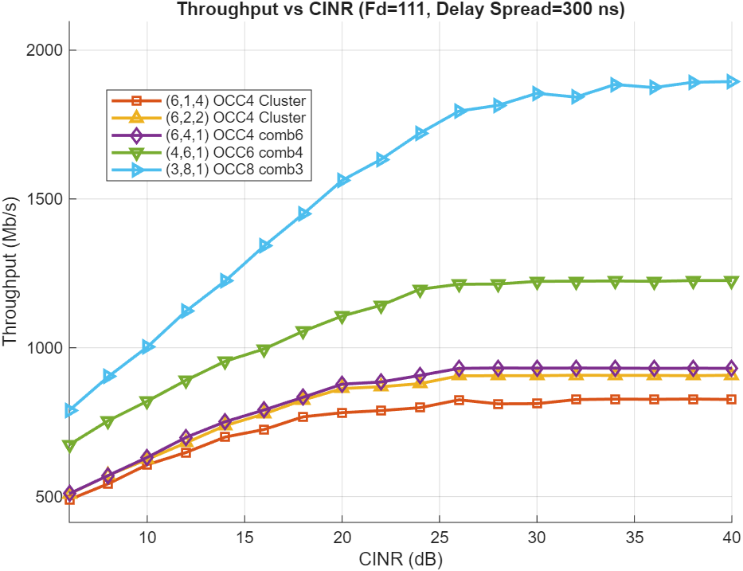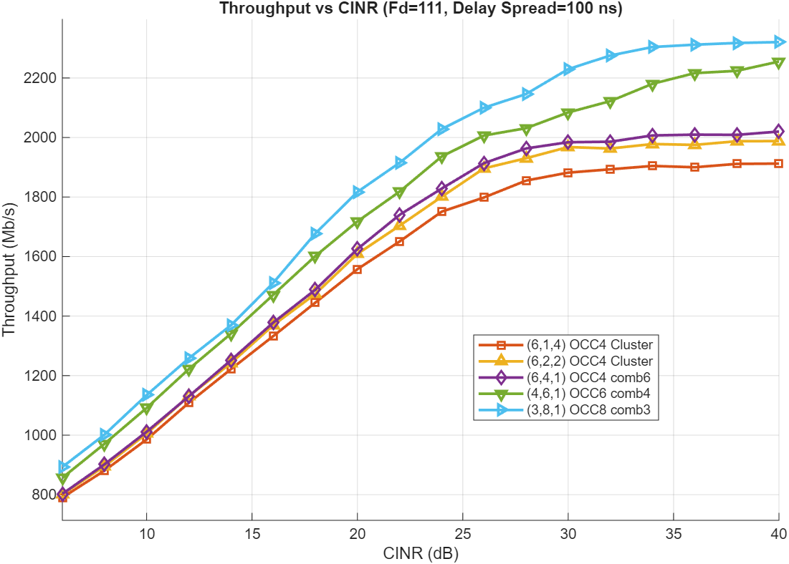
Figure 36. Tput for 24 ports per DMRS Symbol

Observation 11: For 24 ports per DMRS symbols pattern, FD-OCC 8 + comb 3 provides the best Tput performance compared to FD-OCC 4 + comb 6, FD-OCC 6+ comb 4 and block/cluster based + FD-OCC4
Proposal 15: For 24 ports per DMRS symbol FD pattern, support FD-OCC length 8 constructed with nested Kronecker product of three $2×2$ Hadamard matrices with comb-3
Proposal 16: Consider DMRS pattern with comb2/3/4, with FD-OCC 1/2/4/8 for support different number of orthogonal DMRS ports if more orthogonal DMRS ports are needed
Based on the simulation results, a comb‑2/3 DMRS tone pattern with configurable FD‑OCC lengths, tailored to different UE port‑multiplexing requirements, consistently provides the best throughput performance when jointly considering channel delay spread robustness and DMRS overhead efficiency. In 12 ports per DMRS symbol results, the FD-OCC4+comb3 performs better than the NR eType-2. These results suggest that a unified comb‑based FD‑DMRS design may be sufficient, potentially eliminating the need for maintaining separate type‑1 and type‑2 DMRS pattern classes, as is currently the case in NR.
Proposal 17: Instead of having multiple DMRS types like in NR, strive to design a single class of comb-based FD DMRS patterns, and address different DMRS overhead and channel delay spread handling tradeoffs.
For longer FD-OCC lengths constructed via nested Kronecker products (e.g., FD-OCC 8 = $W_{2}⊗W_{2}⊗W_{2}$), the resulting OCC sequence naturally exhibits a multi-stage hierarchical structure, consisting of an inner code and one or more stage of outer codes. Such a construction enables different effective OCC lengths to be implicitly embedded within the same long OCC set (e.g., OCC-2 and OCC-4 embedded within OCC-8).
From a receiver perspective, this nested structure can be beneficially exploited if the DMRS port-to-OCC mapping follows the hierarchy of the outer codes. Specifically, mapping DMRS ports such that ports are first allocated to OCCs sharing the same outer code, and only subsequently across different outer codes (and further, across higher-stage outer codes if present), ensures that a subset of ports mapped within the same outer code group remains mutually orthogonal under partial OCC combining.
This mapping enables a UE scheduled with a long OCC (e.g., FD-OCC 8) to opportunistically perform a reduced-length OCC channel estimation, such as an OCC-2-equivalent estimation, when MU UEs occupying other outer-code groups are not detected or are sufficiently weak, and the channel exhibits large delay spread or high frequency selectivity, where shorter OCC averaging in frequency provides improved channel estimation robustness.
In such scenarios, collapsing the estimation across only the inner code (or first-stage outer code) effectively increases the DMRS frequency density seen by the UE, improving channel estimation quality without requiring any change in the transmitted DMRS pattern. When strong MU interference is present across all outer-code groups, the UE can still revert to full-length OCC processing to preserve orthogonality.
Proposal 18: For DMRS port to long nested OCC code mapping, map the port to the OCC with the same outer code first and then across different outer code; for multi‑stage nested constructions, map across higher‑stage outer codes at later stages.

TD/FD DMRS Pattern for UE Sliding Window Decoding
In 4G LTE, CRS is always on and UE assumes coherent processing across multiple slots/subframes for channel estimation with superior channel estimation performance. In 5G NR, self-contained slot structure was considered as the foundation of PDSCH design to better support beamforming based transmission schemes. DMRS patterns were optimized assuming within-slot channel estimation processing. Typical 5G DMRS pattern has two looks of DMRS occurrence at the beginning and towards the end of the slot. As a results, UE implementation may need to buffer the entire slot to get all the DMRS symbols for the joint channel estimation of the entire SLIV before the CB decoding can start. In 6GR designs as bandwidth and MIMO dimensions continue to scale, how to keep the UE frequency domain buffer small and to keep the processing delay small (based on lessons learned from both 4G LTE CRS and 5G NR DMRS designs) become more important. Furthermore, the long SLIVs proposed earlier require UE to buffer typically higher number of time-domain DMRS symbols than a regular slot for a joint estimation. Keeping these factors in mind, for 6GR UE, we may need to introduce sliding window-based channel estimation and decoding to guide DMRS design as shown in Figure 37. In the example, the channel estimation and CB decoding is performed within the 7-symbol sliding window with a stride of 6 symbols. In the 1st sliding window (SLW), channel estimation is based on symbol #1 and #7 and then the CBs between #1~#7 can be decoded. After CB decoding, the frequency samples between symbol #1 ~ #6 can be discarded. In the 2nd SLW, channel estimation is based at least on symbol #7 and #13 and then the CBs between #7~#13 can be decoded.
For more than 1 look DMRS in a slot/SLIV, we may want to think about new DMRS pattern with more looks in time while preserving or reduce RS overhead against NR baseline. For example, instead of configuring 2 looks type-1 DMRS (comb-2) symbols at symbol @ 2 and 12, we can configure 3 DMRS symbols at symbol 2, 7 and 12 with comb-4 FD pattern. The comb-4 + 3 looks pattern would allow UE to do sliding windows processing and has even less DMRS overhead compared to comb-2 + 2 looks DMRS.
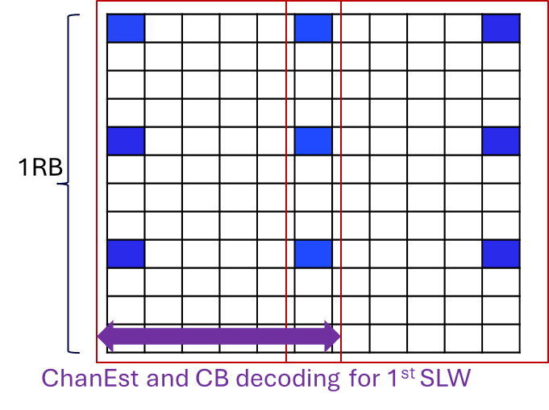
Figure 37. FD buffer saving sliding window operation

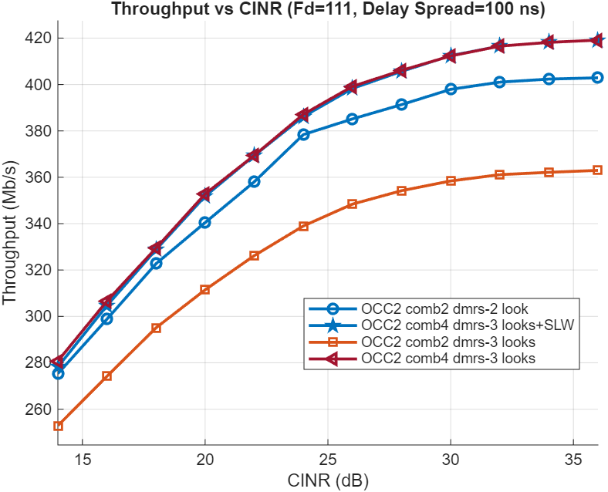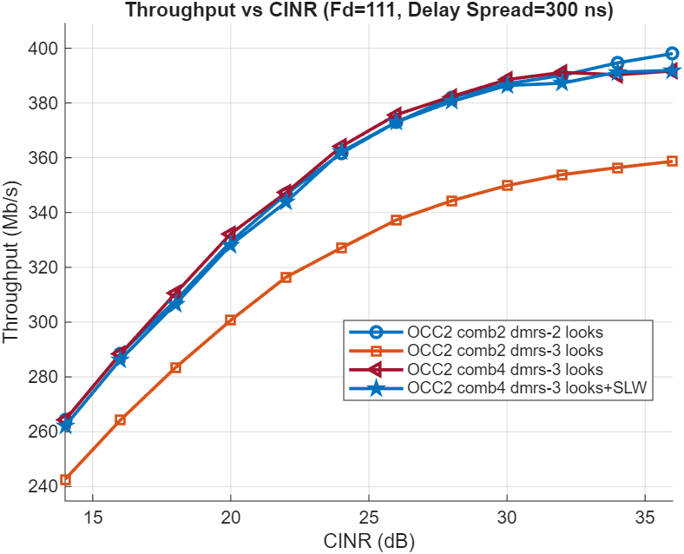
Figure 38. Sliding window processing with 3 looks comb-4 DMRS at 111Hz Doppler frequency
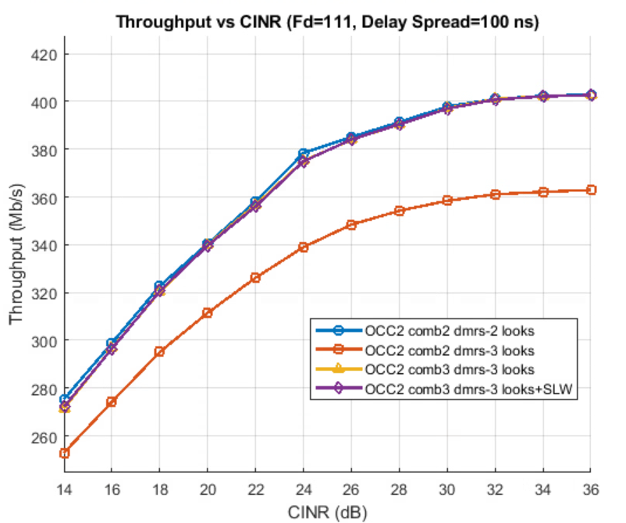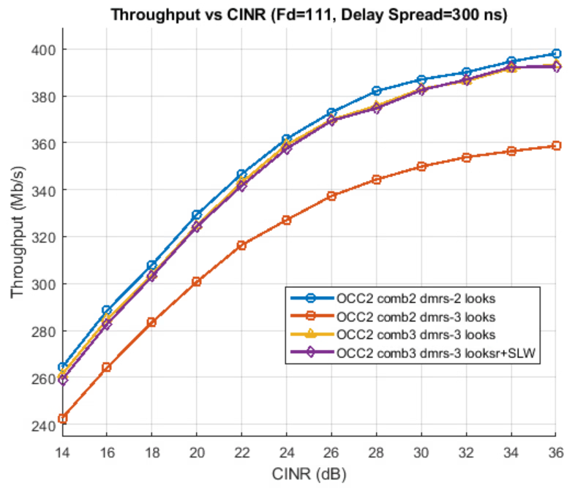
Figure 39. Sliding window processing with 3 looks comb-3 DMRS at 111Hz Doppler frequency

We performed simulations for 3 looks comb-3/4 DMRS pattern + FD-OCC2 with full slot or sliding window operation, and the legacy 2/3 looks comb-2 DMRS + FD-OCC2 with full slot processing. The simulation setup is the same as in 4.1.2 except that the bandwidth is 20MHz and the results are shown in Figure 38 and Figure 39. For delay spread 100ns, the 3 looks comb-4 DMRS pattern with sliding window operation (SLW) has 5%/16% Tput gain over 2/3 looks comb-2 DMRS pattern with full slot processing which is due to the 25%/50% DMRS overhead saving. For delay spread 300ns, the DMRS saving gain of comb-4 DMRS pattern are reduced since comb-4 DMRS has larger channel estimation error in highly frequency selective channel. The 3 looks comb-4 DMRS with SLW only has slight loss for CNR>30dB w.r.t. 2 looks comb-2 DMRS with full slot processing. When we increase the DMRS frequency from comb-4 to comb-3, Figure 39 shows that the sliding window operation is on par with the full slot 2 look DMRS with full-slot processing for delay spread 100ns, but starts to show loss w.r.t 2 looks DMRS with full-slot processing for delay spread 300ns.
Overall, the results show the possibility of replacing 2 looks type-1 DMRS with 3 looks comb-4 DMRS which can enable UE to perform sliding window as needed with marginal performance loss in normal operation region.
Observation 12: UE sliding window operation for channel estimation and CB decoding may be helpful in reducing the FD buffer requirement and the decoding delay
Observation 13: Replacing 2 looks type-1 DMRS with 3 looks comb-4 DMRS allows sliding window operations with almost no Tput performance loss w.r.t. full slot processing in normal operation region
Proposal 19: Study UE FD buffer friendly time/frequency domain DMRS pattern which allows sliding window channel estimation and decoding process while maintaining the full-slot processing performance

In the following, we further study the Doppler operation region of sliding window operation where we don’t see performance loss w.r.t. full slot processing. Fig. 20 shows the throughput performance of fixed DMRS patterns from Section 4.1.1 with a sliding window of channel estimation applied in time domain at different SNR values. The sliding window size considered here is 7 symbols for fixed DMRS patterns (i.e., 2 windows for a 14-symbol slot). For the fixed DMRS, the sliding windows are from symbols (0-7,7-13). It can be seen from the plots at various SNR values that at mid to low doppler ranges, there is no performance difference with sliding window of channel estimation; there is some performance loss as the operating doppler increases. The effective doppler at which sliding window starts to see performance loss compared to no sliding window implementation is dependent on the CINR; at 15 dB, there is negligible delta till 1400Hz (~215 km/h of UE speed), whereas at 25dB, the delta is negligible till 700 Hz (~108 km/h). This phenomenon is due to channel estimation quality being limited by number of DMRS looks within each processing window rather than thermal noise at high SNR values.
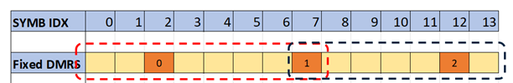
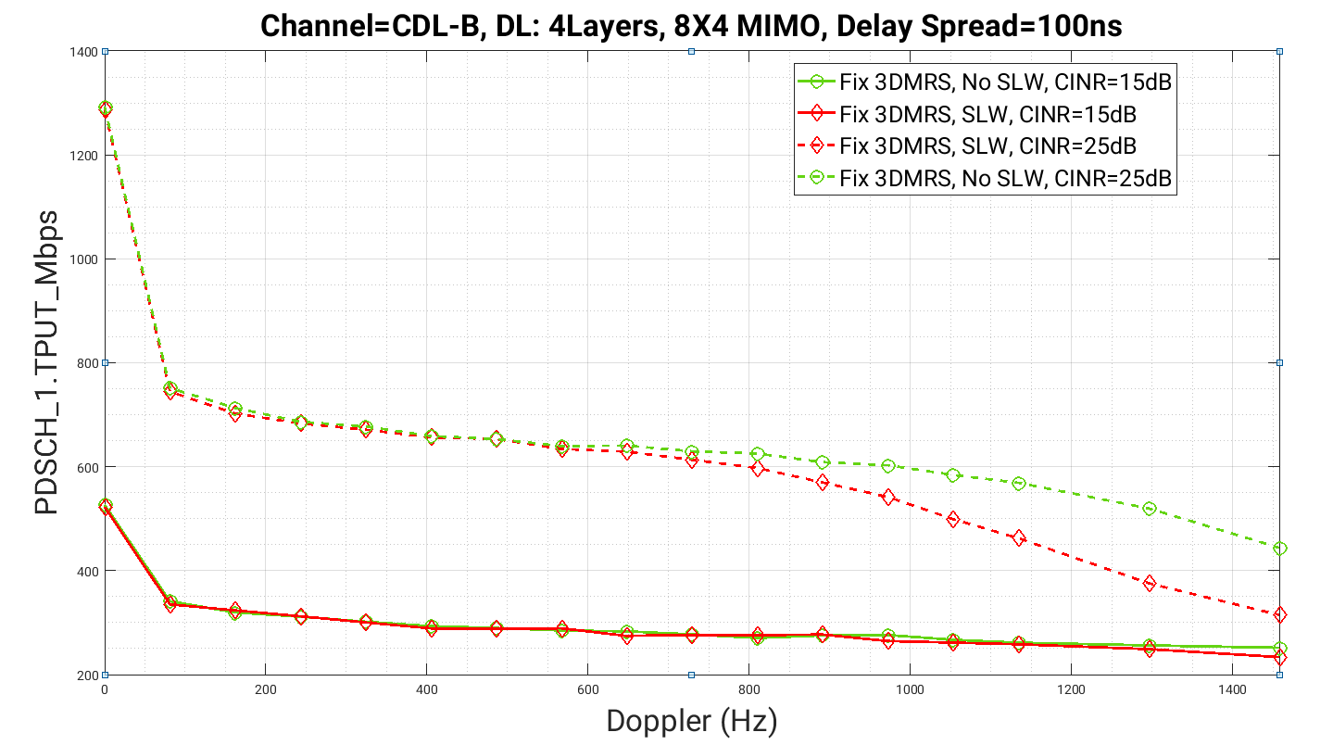
Figure 20. Throughput comparison with sliding window operation for enhanced Type A fixed DMRS patterns

Observation 14: With 3 looks DMRS pattern, the sliding window operation has almost no Tput performance loss w.r.t. full slot processing for Doppler $≤500Hz$ and UE by implementation can allow sliding window operation.

DMRS overhead reduction in time domain
For a given PDSCH, the discussion in Section 4.1 is trying to come up with the lowest DMRS overhead in time and frequency domain given Doppler and delay spread. In this section, we further consider if there is any chance to do even better than that.

DMRS sharing across PDSCH for overhead reduction
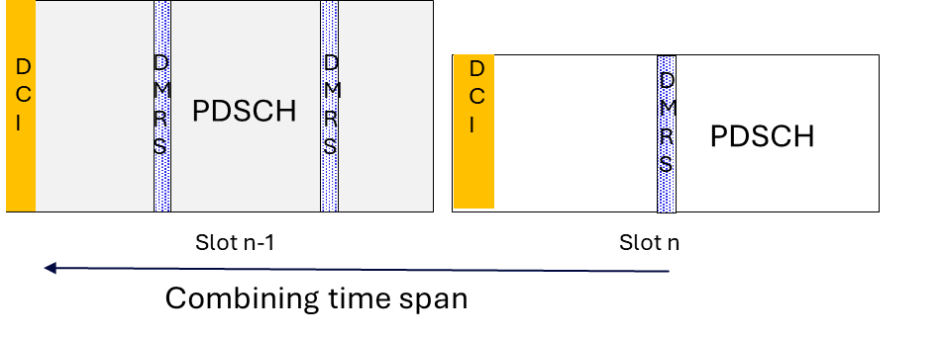
Figure 40. DMRS sharing across two PDSCH
When a UE receives multiple back-to-back PDSCHs from gNB, to estimate the channel in slot #n for PDSCH decoding as shown in Figure 40, the UE may be able to exploit the DMRS transmitted in the previous slot(s) when precoders are the same. This is not an atypical case, as CSI reporting or SRS transmission period is typically not very small due to system overhead implications, thus the gNB may not have the motivation to change the precoders very frequently when a good precoder is found.
As illustrated in Figure 40 in slot #n-1, the UE may be instructed to keep the DMRS tones or channel estimation to be used again in the later slot. In slot #n, the DMRS tones or channel estimation in slot #n-1 can be used again for the demodulation of data REs in slot n, possibly together with the fresh DMRS in slot n. The DMRS pattern in each slot may also depend on the DMRS sharing or not. E.g., if there is earlier DMRS in previous slot, the DMRS in the current slot can be later or sparser (to be more efficient).
To share DMRS, some signalling support might be needed, as only gNB knows if the DMRS can be shared (precoder is the same or not). A simple solution might be including bit field in DL grant DCI to directly indicating if same precoder is applied.
Proposal 20: Study the performance and signalling support needed for DMRS sharing across PDSCHs or slots, when the same precoder is applied over these PDSCH and FDRA is the same (or at least overlaps).

PT-RS enhancements to handle phase/amplitude discontinuity for DMRS overhead reduction
Since NR has a rigid slot boundary concept where PDSCH does not cross, in many implementations, the transmitter and receiver RF takes advantage of the slot boundary of RF changes, such as LNA gain state change, PA adjustment, etc. Such RF changes may lead to phase (and amplitude) glitches across the boundary, where the phase continuity is not guaranteed, and there may be small amplitude changes as well. This leads to the effective observed channel across the boundary not being continuous and requires separate DMRS to be added, which translates to higher DMRS overhead and restriction that PDSCH does not cross such boundaries.
It turns out that that the RF glitches are typically wideband, i.e., a single phase rotation or gain change is applied to all tones in the allocation. The motivates us to consider, what if we insert some light overhead RS to estimate the phase/amplitude glitch across the boundary first and then estimate the channel jointly using DMRS on both sides. The idea is illustrated in Figure 41. Since only a single parameter needs to be estimated (essentially a single complex number) for phase and amplitude change, the new inserted RS has strong similarity with the NR PTRS design. We just need a very low number of REs (10s of REs level) as close to the boundary as possible to estimate the RF glitch in the presence of Doppler shift, and if there is a DMRS close to the boundary already, DMRS REs can be directly used.
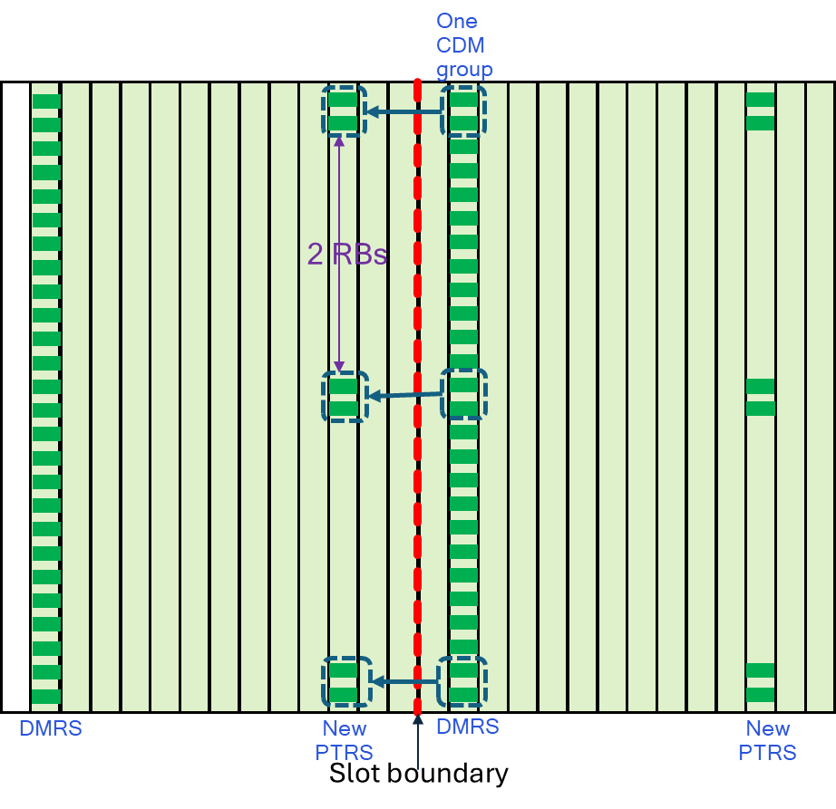
Figure 41. Low density PTRS at the slot boundary
Observation 15: With PTRS to estimate sudden phase/amplitude changes across known boundaries, DMRS sharing across the known boundaries can be supported, effectively reducing DMRS overhead and/or improving channel estimation quality
Proposal 21: Study PTRS enhancement to handle sudden phase/amplitude changes across known boundaries (say slot boundary)

To study the DMRS sharing gain across two contiguous slot, we performed simulations based on two kinds of slot structures as shown in Figure 42 for PDSCH transmission with random phase jump at slot boundary, and the rest of the simulation assumptions are summarized in Table 5. The NR baselines are without the new PTRS insertion and the Tput chosen for comparison is the best among 1 and 2 symbol DMRS slot structure similar to Figure 42. Figure 43 shows the Tput gains of 2-slot DMRS sharing (with new PTRS to estimate and compensate the random phase jump) w.r.t. the NR baselines. Overall, we observe ~6.6% Tput gains over NR for $F_{d}=5Hz$ and $\sim 10\%$ Tput gain over NR for Doppler $F_{d}$=50~400 Hz.

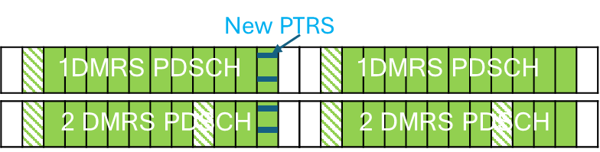
Figure 42. Two slot structures: 1 DMRS and 2 DMRS

Table 5. Simulation parameters for DMRS sharing and slot boundary phase jump
Simulation Assumptions
Carrier freq | 3GHz
BW | 100MHz, SCS=30KHz, 272RBs
Channel | TDL-C 300ns with Fd=5/50/100/200/300/400Hz
Antenna | gNB 4T UE 4R and all DMRS ports are coherent
New PTRS | 2 RE every X=8RB
Phase jump | Phase jump at slot boundary ~uniform($-π,π$)
PDSCH | 12 symbols, 4RB PRG
DMRS | 1 or 2 DMRS @ #2 or #2&10
Layer | 1/2/3/4 with rank adaptation
ChanEst for DMRS sharing | Non-causal cross-slot DMRS combining (combines with DMRS in later slot for ChanEst of current slot). In the end of 25 slot burst, causal cross-slot combing is performed

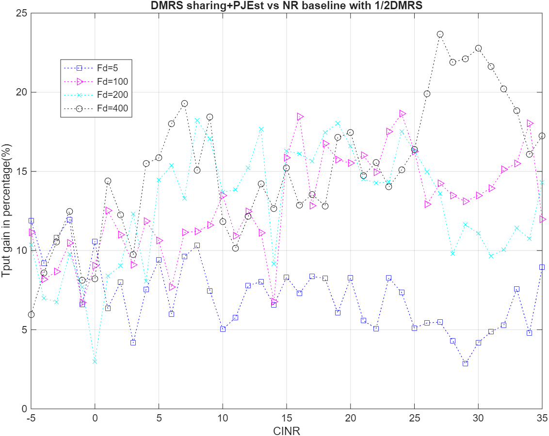
Figure 43. DMRS sharing across two slots v.s. NR 1/2 DMRS(no DMRS sharing)

Study DMRS overhead reduction in frequency domain
For 6GR, it is desirable to study low frequency density DMRS designs to contain DMRS overhead. With advanced receiver processing, including the use of AI/ML based data-driven design and/or non-AI based legacy data aided channel estimation, it may be possible to further reduce DMRS overhead in frequency domain, thereby allowing more number of REs to be used toward PDSCH and PUSCH for higher throughput, on top of the DMRS overhead reduction techniques in time domain as described in Section 4.2 and 4.2.2. One example of sparser DMRS pattern in frequency domain is illustrated in Figure 44, where the DMRS density is half of legacy Rel-15 type 1 DMRS. Assuming 2 DMRS symbols per slot, 12 more REs per RB can be used to transmit data instead of DMRS, which is 7.14% throughput enhancement for data. The following Table 6 summarizes the potential throughput gain with sparser DMRS in different DMRS settings. One can notice that the gain of reducing DMRS in frequency domain saturates with sparser DMRS. Furthermore, because techniques in in Section 4.2 and 4.2.2 can be used to reduce DMRS overhead in time domain, the scenarios of 3, 4 DMRS symbols per slot are rare.
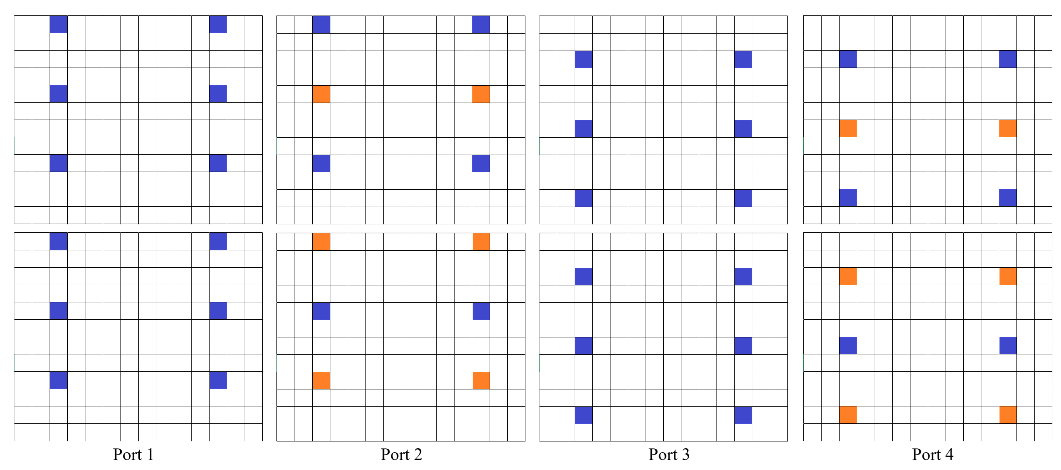
Figure 44. An example of sparser DMRS pattern in frequency domain

Table 6. Upper bound of throughput gain with sparser DMRS
 | 1 DMRS symbol per slot | 2 DMRS symbol per slot | 3 DMRS symbol per slot | 4 DMRS symbol per slot
Density of DMRS = 1/2 density relative to Rel-15 DMRS | 3.57% | 7.14% | 10.71% | 14.28%
Density of DMRS = 1/4 density relative to Rel-15 DMRS | 5.36% | 10.72% | 16.08% | 21.44%
Density of DMRS = 1/8 density relative to Rel-15 DMRS | 6.35% | 12.7% | 19.05% | 25.4%

Observation 16: the gain of further reducing DMRS density in frequency domain on top of other time domain reduction techniques is noticeable, but not significant.
However, the benefit of further reducing DMRS density in frequency domain at transmitter comes with a cost at receiver, which is the complexity of advanced receiver, either with AI based and/or non-AI based data aided channel estimation. In past RAN1 meeting, various potential approaches proposed by companies toward DMRS overhead reduction include:
- Regular DMRS pattern (similar to those in 5G NR) with lower density (sparser in time and/or frequency)
- Superposed DMRS data
- Learned constellation for “pilotless” transmission
- Hybrid of above
Most of the companies studied the performance gain of those approaches but did not study the associated complexity with them. In our view, the study of receiver complexity associated with each proposal is equally important as the gain of the proposal. 3GPP should carefully study the trade-off between performance gain and complexity of the proposed DMRS frequency density reduction technologies, before adopting any of them.
Proposal 22: Receiver complexity associated with frequency sparse DMRS should be carefully studied, together with potential performance gain.
Besides the receiver complexity with advanced receiver, as stated in the 6GR study objective (RP-251881), “6GR and RAN design shall ensure that the 6G System can also operate without AI/ML”. Therefore, 6GR should have baseline DMRS pattern(s) that do not require advanced receiver processing. The reduced DMRS overhead pattern to be studied should be an optional feature that can be supported by UEs capable of advanced receiver processing.
Proposal 23: Baseline DMRS pattern(s) for 6GR should work without advanced receiver. Sparser DMRS pattern in frequency domain, if justified after performance and complexity study, should be an optional feature.

Performance study of DMRS overhead reduction in frequency domain with advanced receiver
In this subsection, we provide evaluation results for DMRS overhead reduction with advanced receiver processing. We used neural-network (NN)-based data-aided channel estimation (DACE) or NN-based joint channel estimation demod as a proxy for advanced receivers for the evaluation purpose.
In the following figure, we considered
- 5G NR DMRS pattern, with classical receiver (robust MMSE channel estimation and MAP detection)
- 5G NR DMRS pattern, with NN receiver
- Superimposed DMRS and data, with NN receiver
- Pilotless learned constellation, with NN receiver
Evaluations were done for SISO TDL-C channels with 300ns rms delay spread and 60km/h. Evaluated metrics are uncoded BER and associated goodput. Here, goodput is defined as (1-BER) * ModOrder * # data REs / # total REs. No channel coding was applied in the evaluations.
From the evaluations, it is observed that the NN-based receivers can successfully perform channel estimation and demodulation under lower DMRS density, thereby achieving increased goodput.
Moreover, it is observed that superimposed DMRS and data can achieve the same performance as pilotless schemes. Therefore, it seems that pilotless approach is not justified.
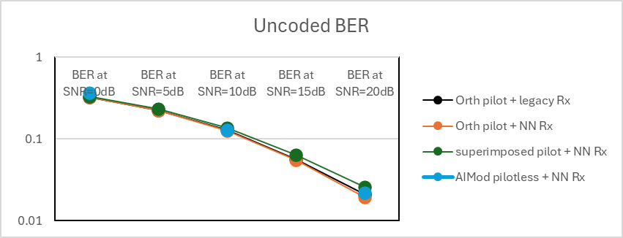

Figure 45. Uncoded BER with various DMRS overhead reduction methods

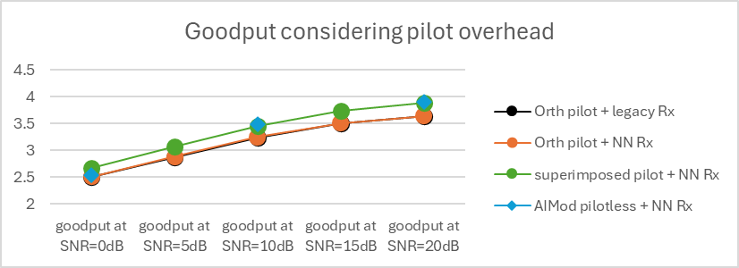
Figure 46. Goodput with various DMRS overhead reduction methods

Observation 17: For DMRS overhead reduction, superimposed DMRS and data can achieve the same performance as pilotless scheme. There is no strong justification to pursue pilotless scheme due to its large complexity.
Next, in the following, evaluations were performed for 1x4 SIMO TDL-C channels with 300ns rms delay spread and 60km/h (222.2Hz Doppler). Channel estimation was performed over the PRG size of 4 RBs. Evaluated transmission and receiver schemes include
- Orthogonal DMRS with full density (“ortho-2”) + LMMSE channel estimator with genie PDP knowledge (“GMMSE”). This serves as the optimistic baseline for comparison.
- Orthogonal DMRS and data with reduced DMRS overhead (“ortho-8”, “ortho-12”, “ortho-16”) + NN-based data-aided channel estimation (DACE)
  - Orth-2,8,12,16 indicates NR-DMRS with the same (Ortho-2) or reduced (Ortho-8, 12, 16) frequency-domain density, where DMRS is placement on every 2, 8, 12, or 16 REs.
- Superposed DMRS and data with AI/ML learned/optimized power allocation for DMRS and data (“SIP”) + NN-based data-aided channel estimation (DACE)
  - At each RE, the transmitted symbol is given by $x=\sqrt{α}p+\sqrt{1-α}d$, where $p$ denotes the known pilot symbol (known QPSK), $d$ denotes QAM data symbol, and $α$ is the power allocation toward pilot
  - For each SNR and modulation order, an optimal power allocation factor $α$ was learned/used via joint optimization of $α$ and the NN-based DACE.
We look at the associated throughput performance for the above evaluation setup. For the evaluations, PDSCH was transmitted over the same 4 RBs. Here, throughput was measured at 10% target BLER. The following figure shows the throughput gain w.r.t. the baseline comparison. As before, the baseline is based on the orthogonal DMRS with full density (“ortho-2”) and genie-PDP-aided LMMSE channel estimator.
From the evaluation results, it is observed that (1) both sparse DMRS pattern and SIP when used with NN-based DACE can achieve throughput gain compared to the baseline scheme of full DMRS pattern and genie-PDP-aided LMMSE channel estimator, and that (2) sparse DMRS pattern with an appropriately-chosen density can achieve nearly similar performance as the power-optimized SIP schemes, except for low SNR (0dB). It is noted that the NN used for evaluation has very high complexity to be used for practical implementation.
Furthermore, one issue with SIP is the difficulty to perform noise + interference estimation. With dedicated DMRS, noise + interference estimation can be done after channel estimation. With SIP, because unknown data and DMRS are superimposed on top of each other, it is very difficult, if not impossible, to estimate noise + interference, unless use a dedicated AI model to estimate/predict noise interference. However, due to the randomness of noise + interference, using AI to estimate/predict noise + interference is a very challenging task.
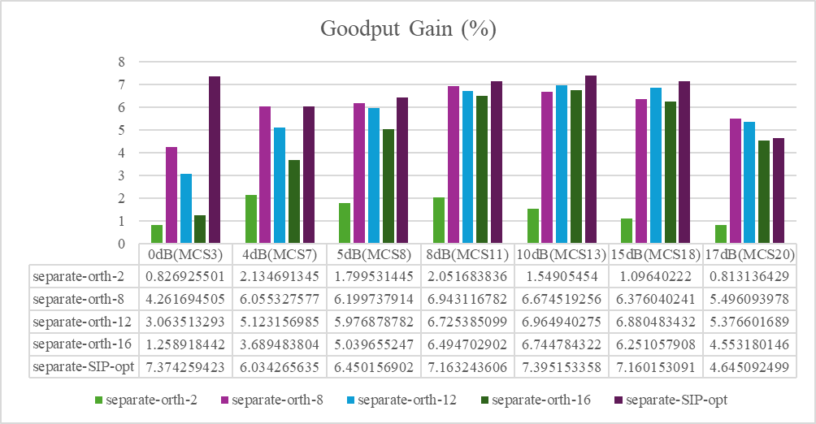
Figure 47. Goodput gain with various DMRS overhead reduction methods
Observation 18: For DMRS overhead reduction, sparse DMRS pattern in frequency domain with an appropriately chosen density can achieve nearly similar performance as the power-optimized SIP scheme. There is no strong justification to pursue SIP scheme due to its large complexity and difficulty of estimating noise and interference.
We further compared the performance of two receivers:
- NN-based data-aided channel estimation and MAP demod (separate model).
- NN-based joint channel estimation and demod (joint model).
The throughput gain comparisons are shown in the table below. The results show only minor difference between the separate and joint models, suggesting that NN-based data-aided channel estimation and MAP demod is sufficient. It should be noted that the joint model requires higher complexity and more training effort than the separate model.
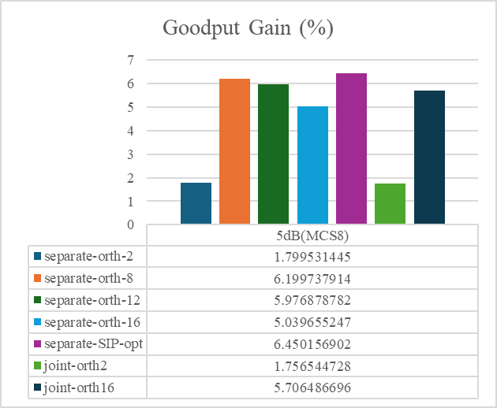
Figure 48. performance comparison between NN based channel estimation with MAP demodulation vs NN based joint channel estimation and demodulation.

Observation 19: NN-based data-aided channel estimation with legacy MAP demodulation can deliver throughput gains comparable to those achieved by NN-based joint channel estimation and demodulation. Therefore, further studying NN-based data-aided channel estimation with legacy domodulation/decoding is sufficient.
In the following, we focus on studying performance of DMRS overhead reduction in frequency domain with NN-based data-aided channel estimation (DACE) in MIMO. The NN is based on Transformer.
To evaluate the performance of the proposed DACE method, we compare it against two baseline schemes. We first compare our method against a robust MMSE estimator (RMMSE). Since neural networks have the potential to overfit to fixed channel profiles, we also include GMMSE as a stronger baseline, assuming perfect knowledge of the channel power delay profile (PDP). Both baselines rely on the dense DMRS pattern (5G NR DMRS pattern) and employ a K-best demapper for data detection, to which we provide a genie noise covariance matrix $R_{nn}=σ^{2}I$. We also include a “Perfect CSI” baseline where the genie channel is provided to the K-best algorithm to show the upper bound of the problem.
In summary, we consider the following channel estimation schemes for evaluation, while assuming genie noise covariance matrix:
- Benchmark
  - Dense DMRS pattern (5G NR DMRS pattern), with robust MMSE (RMMSE) pilot-based channel estimator (PACE)
  - Dense DMRS pattern (5G NR DMRS pattern), with genie MMSE (GMMSE) pilot-based channel estimator (PACE) assuming genie knowledge of power delay profile (PDP)
- Upper bound
  - Perfect CSI
- DMRS overhead reduction
  - Sparse DMRS pattern (50% overhead of the 5G NR DMRS pattern), with NN-based data-aided channel estimator (DACE)
    - We keep the code rate the same across dense and sparse DMRS patterns, by increasing the TB size for the sparse DMRS pattern.
We evaluated the above 4 schemes in the scenario of 32T4R MIMO in relatively low SNR region. The table summarizes simulation assumption and figures below show the results.
 | Scenario 1 | Scenario 2 | Scenario 3
MIMO dimension | 32T4R | 32T4R | 32T4R
Rank | 4 | 4 | 4
Precoder | SVD | SVD | SVD
RB allocation | 4 RBs | 4 RBs | 4 RBs
Channel profile | TDL-C  300ns DS  3Hz Doppler | TDL-C  300ns DS  389Hz Doppler | TDL-C  300ns DS  222Hz Doppler
Modulation and LDPC code rate | 16QAM  r=434/1024 | 16QAM  r=434/1024 | 64QAM  r=466/1024
Number of DMRS symbols in a slot | 2 | 2 | 2
Overhead of dense DMRS (%) | Comb-2 | Comb-2 | Comb-2
Overhead of sparse DMRS (%) | Comb-4 | Comb-4 | Comb-4

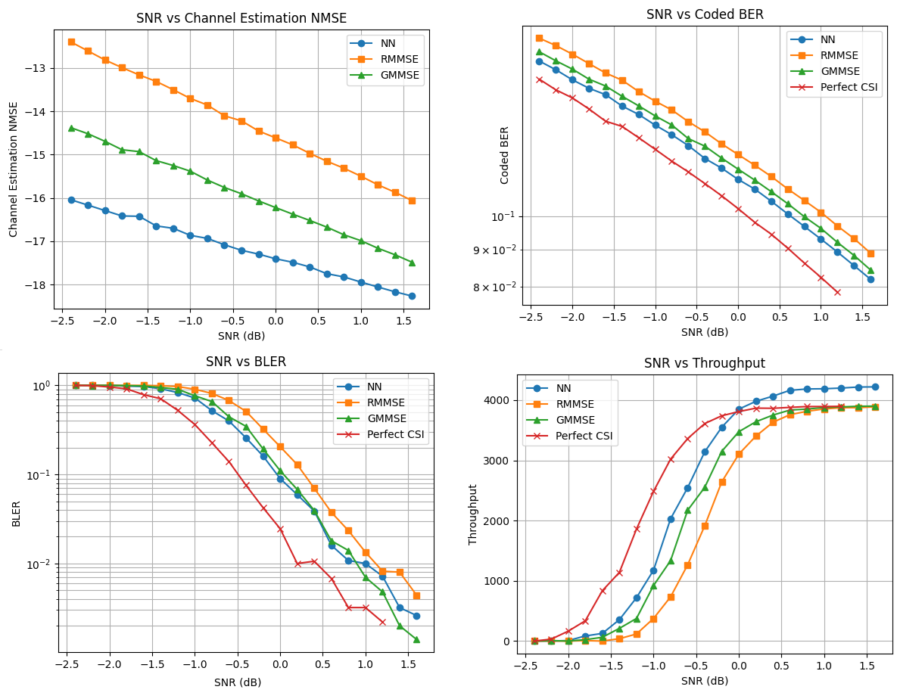
Figure 49. NN model 1 performance in scenario of 32T4R, Rank 4, 16QAM, r=434/1024, TDL-C300, fd=3Hz.
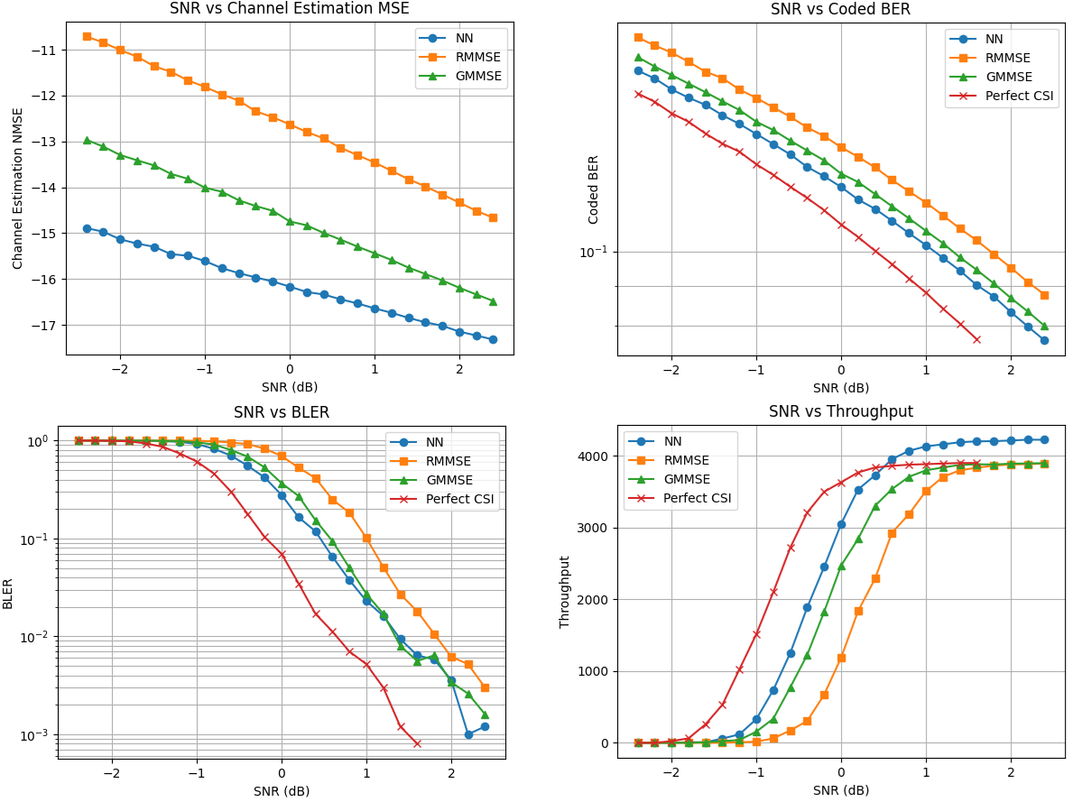
Figure 50. NN model 1 performance in scenario of 32T4R, Rank 4, 16QAM, LDPC r=434/1024, TDL-C300, fd=389Hz.
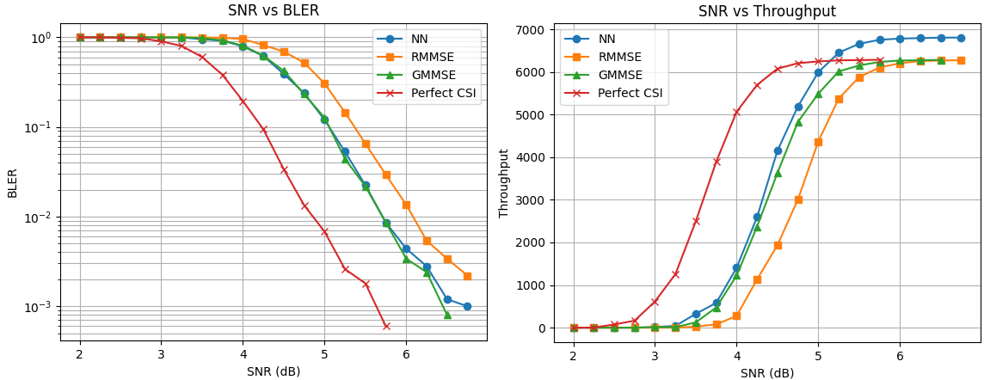
Figure 51. NN model 1 performance in scenario of 32T4R, Rank 4, 64QAM, r=466/1024, TDL-C300, fd=222Hz.
The above simulation results are with TDL-C channel. In the following, the simulation results with CDL-C channel are presented. The simulations in CDL-C channel are with the following key assumptions.
 | Scenario 1
MIMO dimension | 32T4R
Rank | 4
Precoder | SVD
RB allocation | 4 RBs
Channel profile | CDL-C, 300ns DS  11.1Hz Doppler (3 km/h)
Modulation and LDPC code rate | 16QAM, LDPC r=490/1024
Number of DMRS symbols in a slot | 2
Overhead of dense DMRS (%) | Comb-2 (14.3%)
Overhead of sparse DMRS (%) | Comb-4 (7.1%)

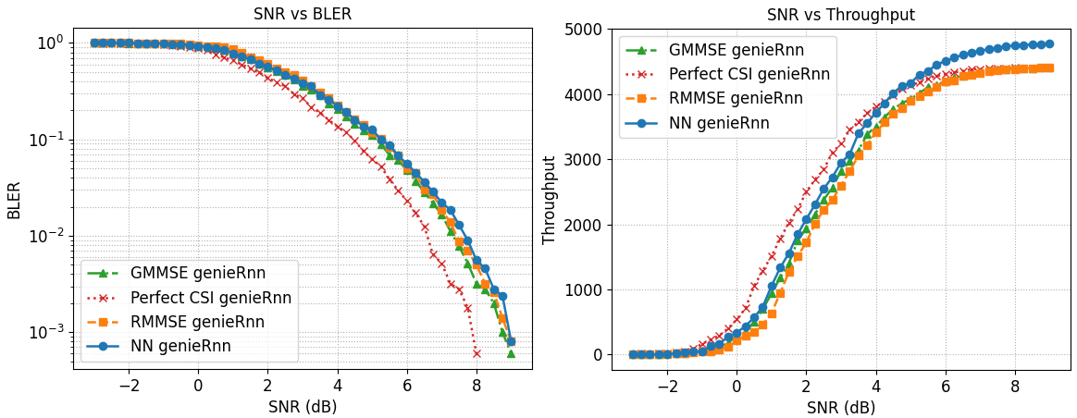
Figure 52. NN performance in scenario of CDL-C 300ns channel with Rank 4, 16QAM.

Based on the above study, NN based channel estimation can work well in low SNR region in CDL-C channel too. In other words, a NN based receiver can work with comb-4 DMRS which yields larger throughput than MMSE receiver with comb-2 DMRS.
Next, we study the performance of NN in medium and high SNR regions. We evaluated a scenario with 4T4R, rank 4 transmission over 4 RBs, 64QAM with LPDC code rate 0.65, in a TDL-C 300ns delay spread and 3Hz Doppler shift. As shown in Figure 54, NN based channel estimation does not work well in high SNR.
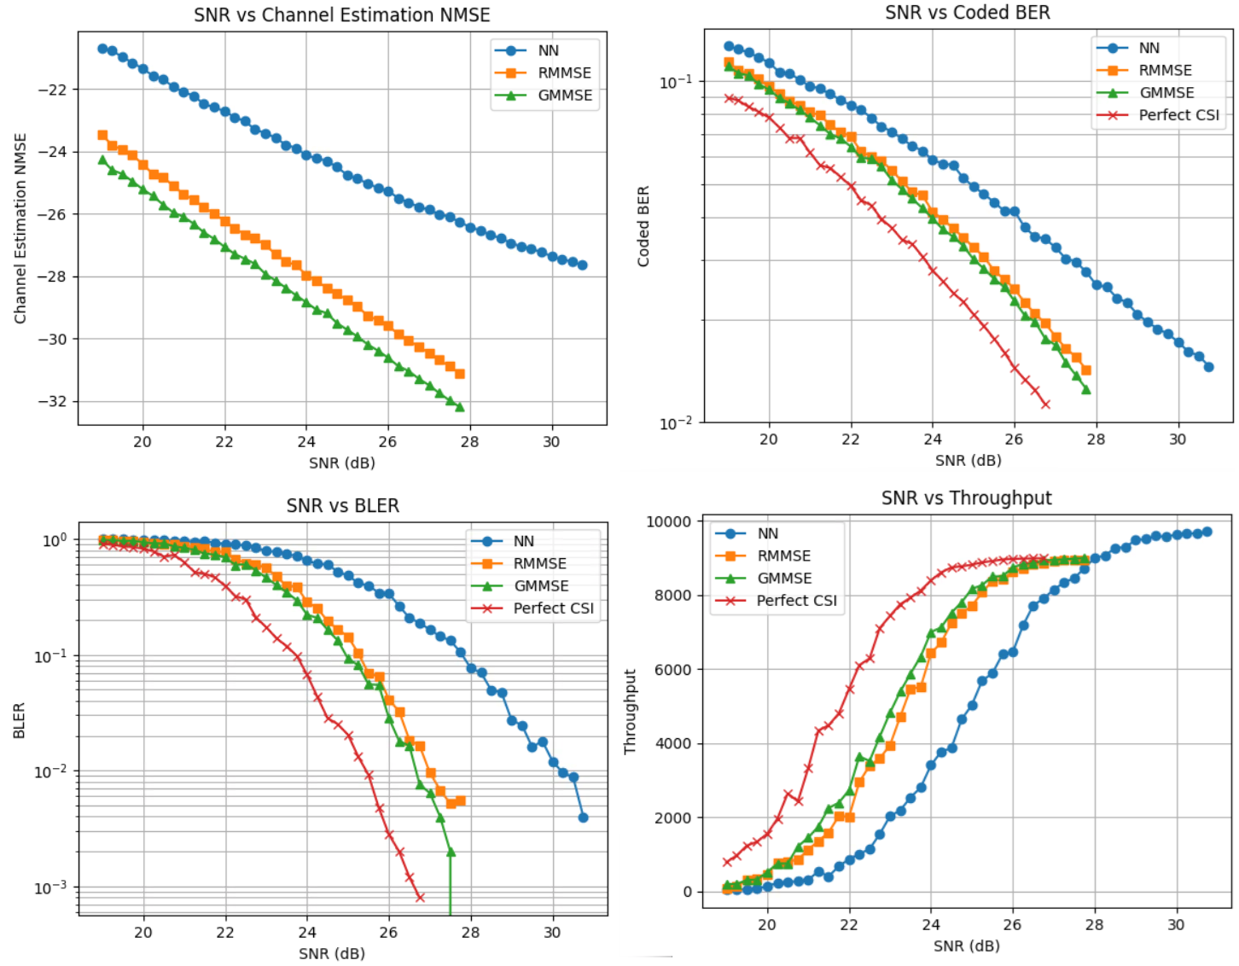
Figure 53. NN model 1 performance in scenario of 4T4R, Rank 4, 64QAM, r=666/1024, TDL-C300, fd=3Hz.
To improve the performance of NN, we train a more complicated NN. We refer the NN used so far as model 1, while the more complicated NN as model 2. The complexity of model 1 and mode 2 are compared with baseline MMSE channel estimation in Section 4.3.1.1. In the following, the performance of model 2 is shown in Figure 54 and Figure 55. Unfortunately, even with a more complicated model with 4 times number of parameters and almost 2 times of FLOPs, NN still does not work well at high SNR region.
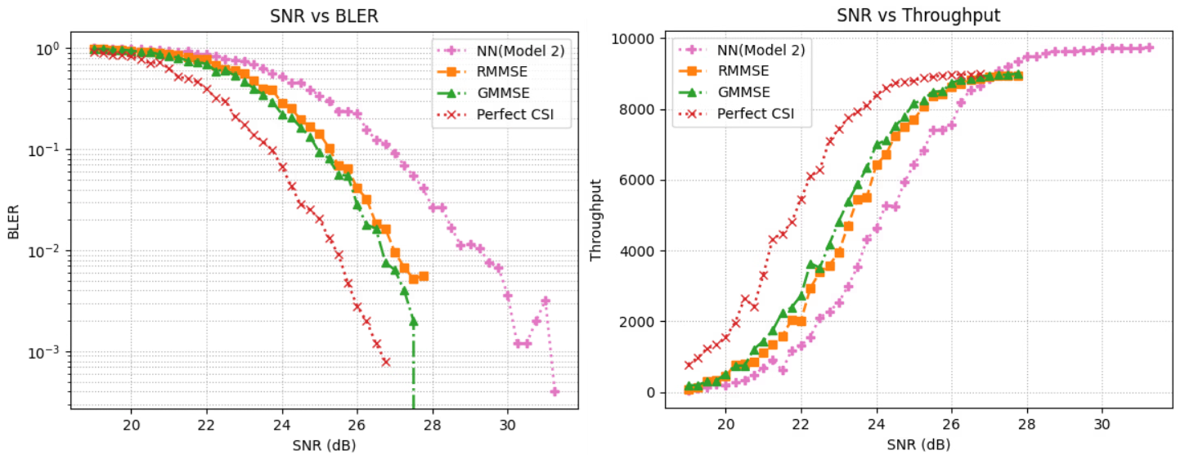
Figure 54. NN model 2 performance in scenario of 4T4R, Rank 4, 64QAM, r=666/1024, TDL-C300, fd=3Hz.
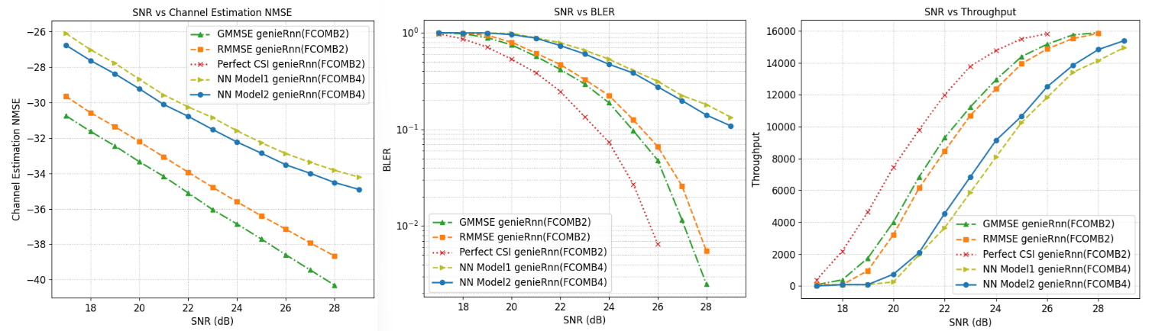
Figure 55. NN model 2 performance in scenario of 32T4R Rank4, CDL-C 300ns, 256QAM, LDPC r=885/1024.

The above observation can be explained by the following analysis. Figure shows the gap of channel estimation MSE between comb-4 and comb-2 FDMRS with MMSE channel estimation. It is observed that MSE gap between comb2 and comb-4 becomes larger at higher SNR. One should notice that the job of NN is using data tones to help channel estimation with comb-4 DMRS. However, due to the gap is larger at high SNR, It is more challenging for NN to bridge the gap between comb-2 and comb-4 at higher SNR which requires more powerful NN model. Beyond a certain point, even very powerful NN model may not work, which is the fundamental reason why NN does not work at high SNR
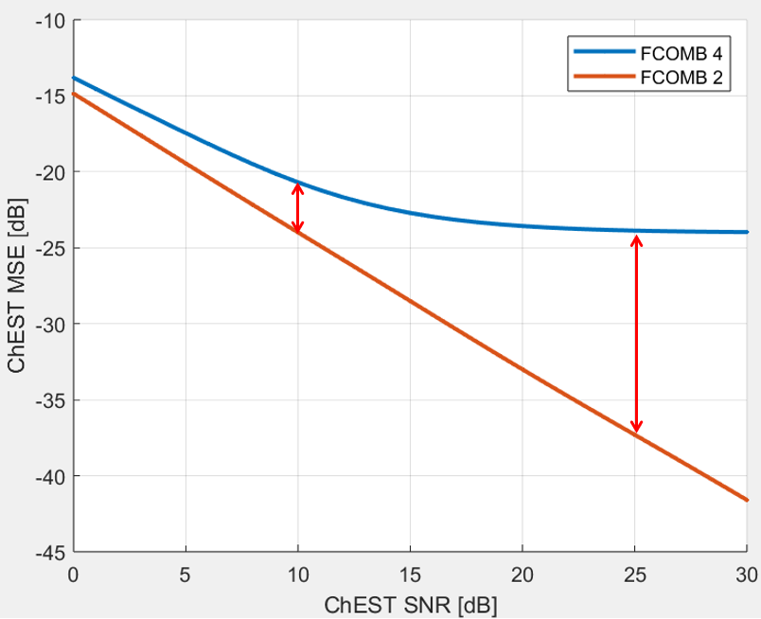
Figure 56. Channel estimation MSE gap between Comb-4 and Comb-2 DMRS with MMSE channel estimation
Based on the above analysis, the following observation is made.
Observation 20: NN-based data-aided channel estimation can work at low SNR, while its performance degrades at high SNR.

Impact of realistic Rnn estimation
An important aspect for performance study of DMRS overhead reduction, which is not in previous section yet, is the impact of sparser DMRS to noise and interference estimation. All the above simulations are with genie noise and interference. With realistic noise and interference estimation, whether sparser DMRS can work or not is an open issue that RAN1 needs to further study. Along this line, one should notice that the impact of sparse DMRS to noise and interference estimation is heavier at uplink, because with massive number of receiving antennas at gNB, estimating the covariance matrix of noise+interference is very challenging, as the matrix size is huge. Sparser DMRS will make this task even more challenging.
In the following, the impact of realistic Rnn estimation to DL DMRS is studied with
$$R_{nn}=\frac{1}{n_{pilots}}\sum_{p}{\left[y_{p} -x_{p}\hat{h}\right]{\left[y_{p} -x_{p}\hat{h}\right]}^{H}}$$
where $n_{pilots}$ is the number of DMRS REs in simulated PDSCH. $y_{p}$ is the observed signals on p-th DMRS tone across all Rx antennas. $x_{p}$ is the transmitted DMRS sequence on p-th DMRS tone. $\hat{h}$ is the estimated channel on p-th DMRS tone.
Firstly, the performance of realistic Rnn estimation is compared with ideal Rnn in TDL 300ns channel with the more complicated NN model 2. Based on the simulation results, the performance degrade of realistic Rnn is noticeable with comb-4 DMRS already. With comb-8 DMRS, the loss is quite large and washes away the gain of NN based channel estimation.

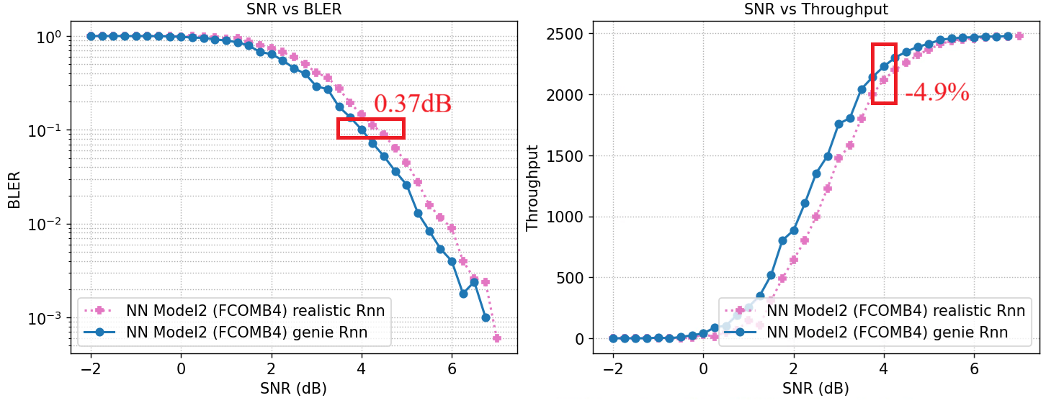
Figure 57. Comparison between realistic and ideal Rnn with comb-4 DMRS in TDL-C 300ns channel with 4T4R Rank 2, 16 QAM, LDPC r = 490/1024, $f_{d}$=3Hz

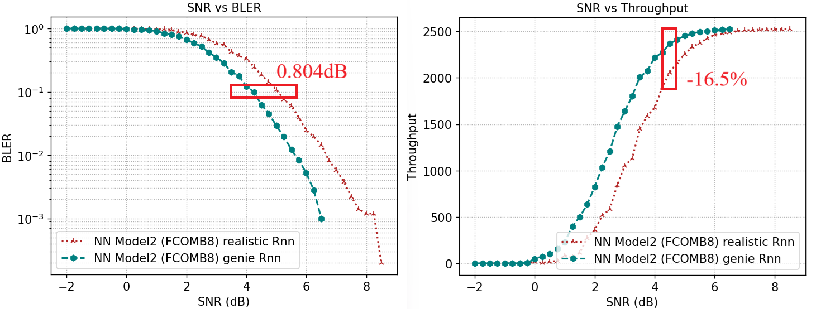Figure 58. Comparison between realistic and ideal Rnn with comb-8 DMRS in TDL-C 300ns channel with 4T4R Rank 2, 16 QAM, LDPC r = 490/1024, $f_{d}$=3Hz
In the following, we plot the performance of receiver with NN based channel estimation and realistic Rnn estimation and comparing it with MMSE based receiver in CDL-C channel. It is further confirmed that NN based channel estimation with realistic Rnn does not work well with comb-8 DMRS.

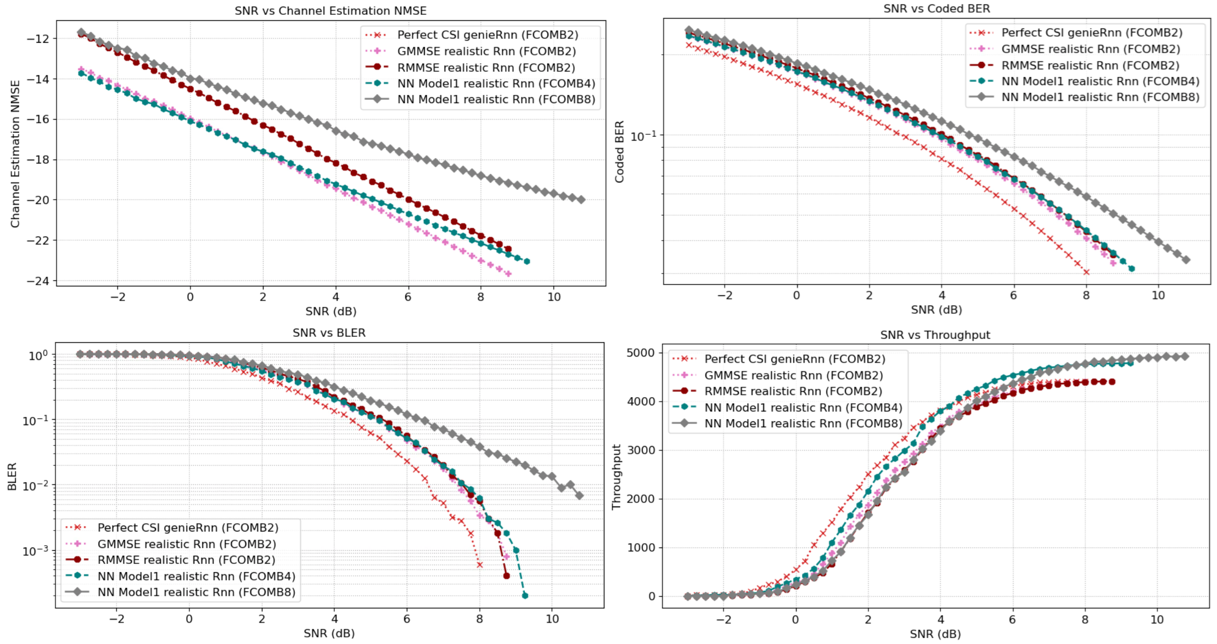
Figure 59. Performance NN with realistic Rnn in CDL-C 300ns channel with 32T4R Rank 4, 16 QAM, LDPC r = 490/1024, $f_{d}$=11.1Hz
Based on the above simulation results, the following observation is made.
Observation 21: Performance gain of NN based receiver over MMSE receiver diminishes with realistic Rnn estimation.
- With comb-4 DMRS, noticeable performance degradation is observed at NN based receiver with realistic Rnn estimation comparing to genie Rnn.
- With comb-8 DMRS, NN based receiver has no gain over baseline MMSE receiver, both with realistic Rnn estimation.

Complexity analysis of DMRS overhead reduction in frequency domain with advanced receiver
Our neural network for data-aided channel estimation (DACE) has around 850K parameters and 230M FLOPs for processing of 4 spatial layers, 4 Rx antennas, and 4 RBs, and two DMRS symbols per RB. In comparison, a naïve implementation of the benchmark MMSE estimator for pilot-based channel estimation involves a single matrix multiplication $\hat{h}=Wy$ over 4 RBs for each Tx-Rx port pair, where $W$ is a (4*168)-by-(4*6*2) complex matrix, $y$ is a 4*6*2=48 dimensional complex vector after de-CDM. This gives 4Tx*4Rx*8*672REs*48REs = 4.2M FLOPs. So, the complexity of NN for data-aided channel estimation (DACE) is significantly higher than that of a benchmark MMSE estimator for pilot-based channel estimation (PACE). Here, we note that DACE will naturally have higher complexity than PACE due to the use of both pilot and data REs. We also note that both NN and MMSE channel estimator have room for optimization toward lower complexity.
The complexity of the two NN models and the MMSE baseline channel estimation are listed in the following table. It is observed that the complexity of both NN model is significantly higher than MMSE baseline.
 | # parameters | # Flops
RMMSE baseline | 258K | 4.2M
NN model 1 | 853K | 230M
NN model 2 | 3.1M | 388M

Observation 22: Neural network based data aided channel estimation (DACE) has significantly higher complexity than MMSE baseline channel estimation.
Furthermore, in RAN1 124, the following agreement was made. It is clear that AI model complexity and model size are two important factors to be considered for DMRS overhead reduction use case.
Agreement
For study/evaluation of the performance and feasibility of AI/ML use cases in 6GR, at least the following may be considered
  - Intermediate performance KPIs (e.g., SGCS), link level KPIs (e.g., BLER) and system level KPIs (e.g., throughput vs overhead), etc
  - Computation complexity/latency (inference/monitoring)
  - Power consumption, if feasible to evaluate
  - Model size
  - Data collection impact
  - Scalability (refer to the examples in TR 38.843)
  - Generalization performance
    - FFS on whether and how to consider realistic deployment scenarios
  - Overhead/complexity associated with data collection, inferencing, performance monitoring, online/site specific fine-tuning, inter-vendor collaboration (if applicable)
  - Online training/fine-tuning training latency, if feasible to evaluate
  - Inter-vendor collaboration impact, if applicable
Note: Details to be discussed per use case.
Note: above aspects may be considered for both AI/ML and non-AI counter part

According to the above agreement, plus for RAN1 to study the complexity of AI/ML based DMRS overhead reduction schemes, the following proposal is proposed.
Proposal 24: Proponent companies of AI/ML based DMRS overhead reduction should report number of parameters of AI/model and number of FLOPs for inference, besides the reported performance gain.

Spectrum aggregation aspects
Currently, regardless of characteristics of the CCs, their associated RRC configurations are completely independent and signaled separately. However, in some scenarios, specifically in intra-band combinations (in FR2 as an example), where the channel characteristics are similar across different CCs, it has been observed that the RRC settings of different CCs are either identical or largely similar. This similarity can be leveraged to not only reduce the signaling overhead, but to also reduce the UE’s memory requirements.
Proposal 25: In 6GR, aimed at reducing signaling overhead and UE’s memory requirements, a more efficient RRC configuration mechanism for CA should be devised.
In legacy CA, scheduling each TB is constrained to the time and frequency resources of each individual CC. When a large number of CCs are aggregated, managing each CC independently increases implementation complexity on the UE side. To address this, relaxing such constraints, particularly in intra-band combinations, can enable more efficient support of CA at the UE, reducing overhead and simplifying resource management.
Proposal 26: In 6GR, study the benefits, feasibility and conditions for pooling time and frequency resources across multiple CCs for DL and UL scheduling at least for intra-band non-contiguous cases.

TB mapping within PDSCH
In RAN1 #124bis, the following agreement is reached for considering the following two options of TB mapping for a PDSCH with FDRA between 200MHz to 400MHz. In this section, we discuss our views on time domain multiplexing of multiple TBs within a PDSCH
Agreement
From frequency domain resource mapping perspective, study TB/CB/CBG mapping within a PDSCH with frequency domain resource allocation between 200MHz and 400MHz considering the following options:
- Option A: A TB can span up to 400MHz
- Option B: A TB can span up to 200MHz
  - FFS details
Note: For both options, whether multiple TBs are time domain multiplexed within a PDSCH due to other restrictions will be separately discussed in agenda item 10.5.2.2.

Time domain splitting of PDSCH into multiple TDMed TBs is proposed by some companies, mainly due to the need to handle larger TB size compared to NR maximum TB size. The proponents mentioned challenging UE implementation in terms large soft buffer memory and need to simplify L1 and L2 HARQ operation and management.
Splitting the PDSCH into multiple TDMed TBs based on max TB size in NR may reduce the buffer size per slot if some TBs passing CRC can be transferred to upper layer. However, UE implementation should size the memory buffer size assuming the worst-case scenario where all TBs fail. When considering the worst case, when all TBs in the same slot fail, no saving can be achieved and modem buffer needs to consider the worst case. Furthermore, a larger number of HARQ process numbers (HPNs) would be needed assuming separate HARQ process IDs for the TDMed TBs. Hence, from UE implementation perspective, UE should budget for same buffer memory regardless there is timed-domain segmentation of the PDSCH or not. Hence, there are no memory buffer savings compared to larger TB.
On the other hand, for multiple TDMed TBs within a PDSCH, there are few design aspects that are not clear with this design approach. For example, when one or more TBs of the PDSCH fail, whether PDSCH re-transmission is only for failed TBs or all TBs. In addition, whether all TBs have same or separate HARQ IDs and if separate whether UE bundles the HARQ A/N of the TBs or not. Multiple HARQ Ack/Nak feedback bits will result in a DL performance loss at cell edge due to worse Ack/Nak reliability in UL. In our companion paper of HARQ related Aspects [1], our evaluation results show the DL throughput loss as a function of number of DL HARQ IDs. Furthermore, If PDSCH allocation changes from one transmission to the other change, multi-TB would further complicate the entire HARQ management process.
Observation 23. Time-domain splitting of PDSCH into multiple TDMed TBs does not provide clear L1 implementation benefits, as reduced per-TB buffer size is offset by increased HARQ process requirements and worst-case memory allocation for all TBs. Furthermore, key design aspects related to retransmission handling and HARQ A/N assignment and bundling remain unclear.
On the other hand, dividing the PDSCH into several sub-TBs in time domain may help parsing some of the MAC headers in case of TB decoding failure. Since the UE knows the location of the MAC headers within each sub-TB, it can help parse the headers within a successfully decoded sub-TBs case of failure of previous sub-TBs. However, since this is mostly L2 benefits, we don't see any need for symbol level alignment for that. Additionally, we don't see strong motivation to have different MCS or coding rate for CBs in different sub-TBs given the associated cost/overhead.
Observation 24. TB splitting in time domain into multiple sub-TBs may provide limited L2 benefit for MAC header parsing, however, it does not justify additional PHY constraints such as symbol-level alignment, or different MCS across sub-TBs. The sub-TB related design should be confined in L2 enhancement, and transparent from L1 perspective, i.e., a single TB over time per slot is assumed regardless of CBW.

Conclusions
In this contribution, we made the following observations and proposals:
For PDSCH frequency domain interleaving:
Observation 1: Improved PRG level interleaving can achieve the same frequency diversity order as the # of PRGs in a CB
Proposal 1: Study a RBB (match the size of a PRG) level block interleaver to maximize the frequency diversity of PDSCH where the interleaving is over all the PRGs allocated for the PDSCH
Proposal 2: Consider the block interleaver depth or the number of rows of the block interleaver to approximately match the number of PRGs a CB occupies.
For transmission scheme enhancements:
Observation 2: Under narrow resource allocation, the CDD gain over PRG-level precoder cycling mainly originates from the higher degree of diversity gain
Observation 3: CDD gain can be further enhanced by employing wideband channel estimation, which is not possible with PRG-level precoder cycling
Observation 4: Explicit indication of the cyclic delay value is beneficial for UE to make a correct assumption on the CDD-shifted channel PDP
Observation 5: Under wide resource allocation, most of the CDD gain over PRG-level precoder cycling is attributed to the realization of the frequency-domain processing gain
Observation 6: Explicit CDD allows the UE to employ CDD precoding with large cyclic delay values when needed
Proposal 3: Study the explicit CDD for 6GR transmit diversity
Observation 7: Staggered CBs in SC-MIMO mapping see better channel quality compared to NR mapping assuming SIC receiver
Observation 8: SC-MIMO mapping enables low-complexity demapping of the low-interference layers
Observation 9: Layer imbalance for rank-2 is too small to affect single-codeword transmissions
Observation 10: Suppressing inter-layer interference provides robust gains in all cases, including layer imbalance
Observation 11: SC-MIMO mapping provides robust performance gains over NR mapping across various transmission scenarios
Proposal 4: Support single-codeword transmission for downlink MIMO
Proposal 5: Study SC-MIMO layer mapping for 6G
Proposal 6: Study MIMO transmission schemes to reduce BICM capacity loss w.r.t. Shannon limit.

For DMRS enhancements for PDSCH:
Proposal 7: For 6GR, support PDSCH designs crossing slot boundaries.
Proposal 8: Study the design of almost uniform DMRS time domain pattern with different target Doppler for SLIVs longer than a slot
Proposal 9: Study how to dynamically indicate the DMRS time domain density
Proposal 10: Study enhanced PxSCH with fixed time domain DMRS candidate locations such as 2/7/12 and potentially remove 4 DMRS looks per slot pattern.
Proposal 11: The PxSCH only supports SLIV patterns which cover at least one DMRS symbol from the fixed candidate locations, e.g. 2/7/12
Proposal 12: Study the maximum number of orthogonal DMRS ports needed in the system level perspective taking into account the DMRS overhead, DMRS channel estimation performance dependent on the channel profile, and imperfect CSI.
Observation 9: From our DL MU-MIMO simulations, more than 24 orthogonal DMRS ports does not help the network total throughput, considering channel estimation loss with larger FD-OCC, higher overhead with more orthogonal DMRS ports, realistic SRS delay, and typical SNR range.
Proposal 13: Support up to 24 orthogonal DMRS ports for PDSCH. Use non-orthogonal DMRS ports if more spatial layers are needed.
Observation 10: For 12 ports per DMRS symbols pattern, FD-OCC 4 + comb 3 provides the most robust Tput performance compared to FD-OCC 2 + comb 6 and NR etype-2 (FD-OCC4)
Proposal 14: For 12 ports per DMRS symbol FD pattern, support FD-OCC length 4 with Comb-3
Observation 11: For 24 ports per DMRS symbols pattern, FD-OCC 8 + comb 3 provides the best Tput performance compared to FD-OCC 4 + comb 6, FD-OCC 6+ comb 4 and block/cluster based + FD-OCC4
Proposal 15: For 24 ports per DMRS symbol FD pattern, support FD-OCC length 8 constructed with nested Kronecker product of three $2×2$ Hadamard matrices with comb-3
Proposal 16: Consider DMRS pattern with comb2/3/4, with FD-OCC 1/2/4/8 for support different number of orthogonal DMRS ports if more orthogonal DMRS ports are needed
Proposal 17: Instead of having multiple DMRS types like in NR, strive to design a single class of comb-based FD DMRS patterns, and address different DMRS overhead and channel delay spread handling tradeoffs.
Proposal 18: For DMRS port to long nested OCC code mapping, map the port to the OCC with the same outer code first and then across different outer code; for multi‑stage nested constructions, map across higher‑stage outer codes at later stages.
Observation 12: UE sliding window operation for channel estimation and CB decoding may be helpful in reducing the FD buffer requirement and the decoding delay
Observation 13: Replacing 2 looks type-1 DMRS with 3 looks comb-4 DMRS allows sliding window operations with almost no Tput performance loss w.r.t. full slot processing in normal operation region
Proposal 19: Study UE FD buffer friendly time/frequency domain DMRS pattern which allows sliding window channel estimation and decoding process while maintaining the full-slot processing performance
Observation 14: With 3 looks DMRS pattern, the sliding window operation has almost no Tput performance loss w.r.t. full slot processing for Doppler $≤500Hz$ and UE by implementation can allow sliding window operation.
Proposal 20: Study the performance and signalling support needed for DMRS sharing across PDSCHs or slots, when the same precoder is applied over these PDSCH and FDRA is the same (or at least overlaps).
Observation 15: With PTRS to estimate sudden phase/amplitude changes across known boundaries, DMRS sharing across the known boundaries can be supported, effectively reducing DMRS overhead and/or improving channel estimation quality
Proposal 21: Study PTRS enhancement to handle sudden phase/amplitude changes across known boundaries (say slot boundary)
Observation 16: the gain of further reducing DMRS density in frequency domain on top of other time domain reduction techniques is noticeable, but not significant.
Proposal 22: Receiver complexity associated with frequency sparse DMRS should be carefully studied, together with potential performance gain.
Proposal 23: Baseline DMRS pattern(s) for 6GR should work without advanced receiver. Sparser DMRS pattern in frequency domain, if justified after performance and complexity study, should be an optional feature.
Observation 17: For DMRS overhead reduction, superimposed DMRS and data can achieve the same performance as pilotless scheme. There is no strong justification to pursue pilotless scheme due to its large complexity.
Observation 18: For DMRS overhead reduction, sparse DMRS pattern in frequency domain with an appropriately chosen density can achieve nearly similar performance as the power-optimized SIP scheme. There is no strong justification to pursue SIP scheme due to its large complexity and difficulty of estimating noise and interference.
Observation 19: NN-based data-aided channel estimation with legacy MAP demodulation can deliver throughput gains comparable to those achieved by NN-based joint channel estimation and demodulation. Therefore, further studying NN-based data-aided channel estimation with legacy domodulation/decoding is sufficient.
Observation 20: NN-based data-aided channel estimation can work at low SNR, while its performance degrades at high SNR.
Observation 22: Neural network based data aided channel estimation (DACE) has significantly higher complexity than MMSE baseline channel estimation.
Proposal 24: Proponent companies of AI/ML based DMRS overhead reduction should report number of parameters of AI/model and number of FLOPs for inference, besides the reported performance gain.
Observation 19: NN-based data-aided channel estimation with legacy MAP demodulation can deliver throughput gains comparable to those achieved by NN-based joint channel estimation and demodulation. Therefore, further studying NN-based data-aided channel estimation with legacy domodulation/decoding is sufficient.
Observation 20: NN-based data-aided channel estimation can work at low SNR, while its performance degrades at high SNR.
Observation 21: Performance gain of NN based receiver over MMSE receiver diminishes with realistic Rnn estimation.
- With comb-4 DMRS, noticeable performance degradation is observed at NN based receiver with realistic Rnn estimation comparing to genie Rnn.
- With comb-8 DMRS, NN based receiver has no gain over baseline MMSE receiver, both with realistic Rnn estimation.
Observation 22: Neural network based data aided channel estimation (DACE) has significantly higher complexity than MMSE baseline channel estimation.
For spectrum aggregation considerations:
Proposal 25: In 6GR, aimed at reducing signaling overhead and UE’s memory requirements, a more efficient RRC configuration mechanism for CA should be devised.
Proposal 26: In 6GR, study the benefits, feasibility and conditions for pooling time and frequency resources across multiple CCs for DL and UL scheduling at least for intra-band non-contiguous cases.
For TB mapping within PDSCH:
Observation 23. Time-domain splitting of PDSCH into multiple TDMed TBs does not provide clear L1 implementation benefits, as reduced per-TB buffer size is offset by increased HARQ process requirements and worst-case memory allocation for all TBs. Furthermore, key design aspects related to retransmission handling and HARQ A/N assignment and bundling remain unclear.
Observation 24. TB splitting in time domain into multiple sub-TBs may provide limited L2 benefit for MAC header parsing, however, it does not justify additional PHY constraints such as symbol-level alignment, or different MCS across sub-TBs. The sub-TB related design should be confined in L2 enhancement, and transparent from L1 perspective, i.e., a single TB over time per slot is assumed regardless of CBW.

References
- R1-2604704, HARQ related Aspects, Qualcomm Incorporated

Appendix A: Example SLM mapping design with Q_m=4 and k=2
This appendix provides one example of the proposed SLM symbol-domain mapping. The purpose of this appendix is to illustrate one possible realization in sufficient details so that the results can be reproduced. The example below considers 16QAM with $Q_{m}=4$ and $k=2$.
Accordingly, the transmitted 4 bits are split into:
- $p_{i-1}=[p_{1} p_{0}]$
- $u_{i}=[u_{1} u_{0}]$
The transmitted symbol is written as
$$\begin{matrix} & x(i)=I(i)+jQ(i). & & \text{(A-3)}\end{matrix}$$For the considered 16QAM example, the in-phase component is given by
$$\begin{matrix} & I(i)=a_{I}(p_{i-1})+v_{I}(u_{i})=(1-2p_{0})+2(1-2u_{1}) & & \text{(A-4)}\end{matrix}$$
and the quadrature component is given by
$$\begin{matrix} & Q\left(i\right)=a_{Q}\left(p_{i-1}\right)+v_{Q}\left(u_{i}\right)=\left(1-2p_{1}\right)+2\left(1-2u_{0}\right) & & \text{(A-5)}\end{matrix}$$Notice that, both $a(p_{i-1})$ and $v(u_{i})$ are standard QPSK modulation in this example, and they are scaled properly such that the resulting constellation after superposition becomes 16QAM.
Numerical example
As shown by the example, once the sub-constellation is determined by $p_{i-1}$, the detector only needs to search over four candidate points instead of the full 16-point constellation.
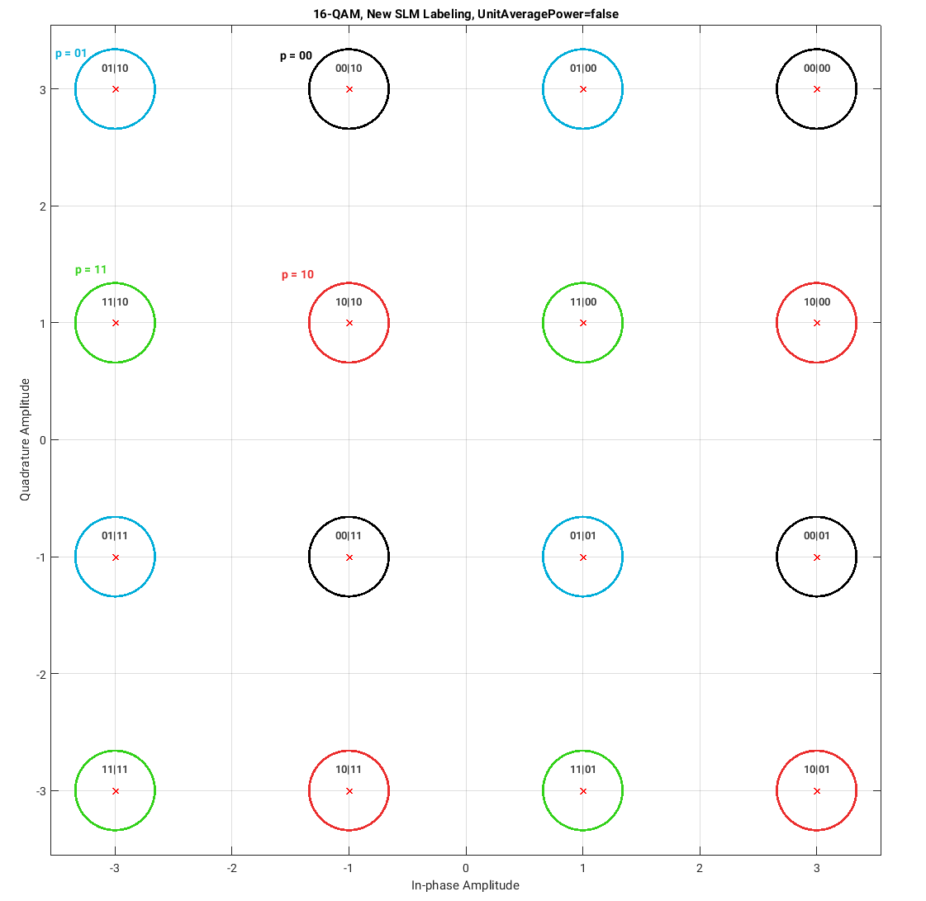
Figure 60. Example of 16QAM mapping for $Q_{m}=4$and $k=2$. The partition-selection bits $p_{i}=[p_{1} p_{0}]$determine the selected 4-point sub-constellation, while the local refinement bits $u_{i}=[u_{1} u_{0}]$determine the final point within that sub-constellation.

Simulation results from RAN1-124bis

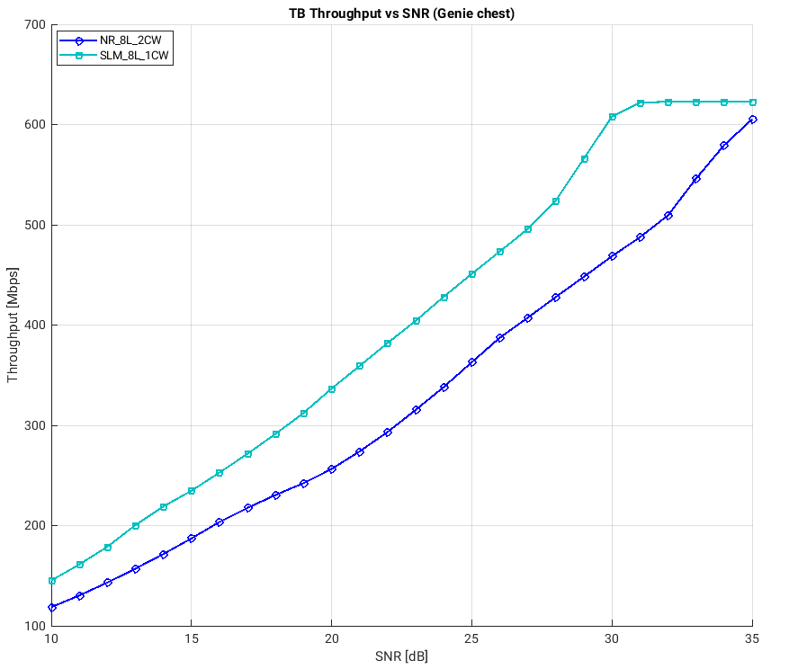
Figure 61- 8L, TDL-A 30ns, 50PRBs, open-loop precoding

Figure 61- 8L, TDL-A 30ns, 50PRBs, open-loop precoding shows that the proposed SLM consistently outperforms the baseline NR mapping over the simulated SNR range under genie channel estimation. The gain increases with SNR and is most pronounced in the medium-to-high SNR region, reaching approximately 130–140 Mbps around 30 dB. In terms of equivalent operating point, the proposed SLM provides roughly 3–4 dB effective SNR gain over a broad throughput range, and up to about 4–5 dB near 600 Mbps.

